**Acid Base reactions**

**2019 (edited)**

Each circled functional group is found in different organic molecules commonly used in school laboratories:





|  |  |  |  |
| --- | --- | --- | --- |
|  | **Functional group** | **Chemical test** | **Observations** |
| **B** |  |  |  |
| **C** |  |  |  |

(ii) Describe an alternative method to distinguish between functional groups **B** and **C**.

Identify the reagent needed, the expected observations, and explain the type of reaction occurring.

**2018**

(a) Two bottles of different colourless organic liquids are unlabelled. They are known to be propan-1-amine,

CH3CH2CH2NH2, and ethanoic acid, CH3COOH.

(i) Explain how you could identify these two liquids using only solid sodium hydrogen carbonate, NaHCO3(*s*).

(b) Give the structural formula and name for the product of the reaction between propan-1-amine, CH3CH2CH2NH2, and ethanoic acid, CH3COOH to form a salt.

**2017**

(a) Describe a simple test that will distinguish between solutions of the final organic compounds B and E.

 

(b) Compounds **B** and **E** react together.

(i) Write a balanced equation for the reaction that occurs between compounds **B** and **E**.

(ii) Identify the type of reaction that occurs between compounds **B** and **E**.

Justify your answer.

**2016**

Solutions of amines are described as bases, and solutions of carboxylic acids are described as acids.

(i) Complete the balanced equation for the reaction between solutions of ethanamine, CH3CH2NH2(*aq*) and hydrochloric acid, HCl(*aq*).

(ii) Explain the statement ‘carboxylic acids have acidic properties’.

Refer to the reaction between ethanoic acid, CH3COOH(*aq*), and water, H2O(l) in your answer.

**2014**

Sodium carbonate, hydrochloric acid, and sulfuric acid are each added to separate samples of two

organic compounds.

The structures of the compounds and the products of any reactions are given in the table below.

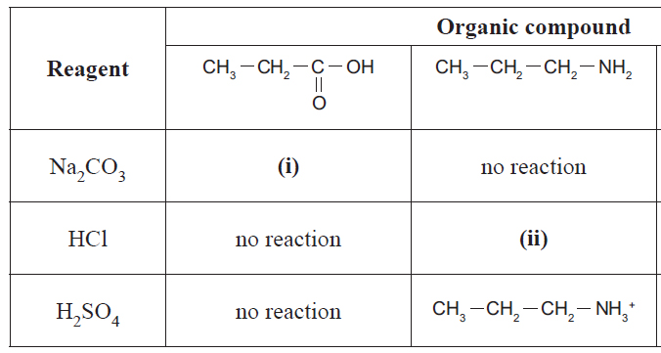

Compare and contrast the reactions that **do** occur between these organic compounds, and the reagents in

the table above.

In your answer you should:

• give the structure of the organic products **(i)** and **(ii)**

• describe the different types of reactions occurring, and give reasons why they are classified as that type

• identify any specific conditions that are required for the reactions to occur.

© <https://www.chemical-minds.com>

NCEA questions and answers reproduced with permission from NZQA