Isomers
Isomers are molecules that have the same molecular formula but different structural formula.
You need to know about 2 types which are 1) Constitutional and 2) Geometric

1) Constitutional aka Structural
chain isomerism | positional isomerism | functional group isomerism
butane  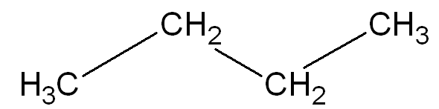 | 1-bromopropane  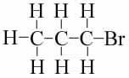 | propanoic acid  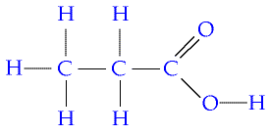
2 methyl propane  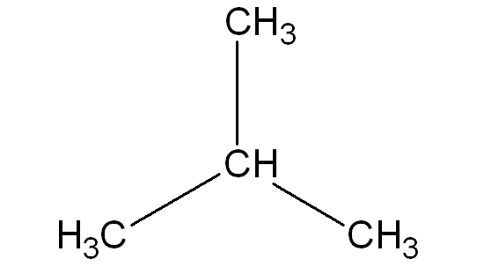 | 2-bromopropane  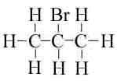 | methyl ethanoate (an ester Level 3 only!)  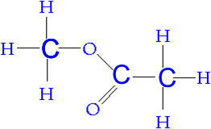
pentane C₅ H₁₂ has 3 isomers  make, draw & name them | make & draw butan-1-ol and butan-2-ol | C₂H₆O has 2 isomers  methoxy methane  (an ether, not required for NCEA Level 2 or 3)  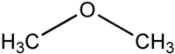  and  try to draw the second isomer of C₂H₆O

2) Stereoisomers
Geometric cis or trans isomers | Enantiomers (for Level 3 Chemistry)
cis-1,2-dichloroethene | trans-1,2-dichloroethene
restricted rotation about a C=C
2 different groups on the left hand side
and 2 different groups on the right hand side
make & draw cis-but-2-ene
and
trans-but-2-ene
additional interesting information (for Level 3 Chemistry)

 | mp (‘C) | bp (‘C)
cis | -80 | 60
trans | -50 | 48
why is the bp of cis higher?
cis is polar trans is non-polar with
permanent dipole forces as well as temporary dipole forces
so
more energy is required to boil the cis isomer so bp is higher

why is the melting point of cis lower?
in a solid state the molecules must pack together efficiently, however the U shape of the cis isomer will not pack as well as the straight shape of the trans isomer
so
less energy is needed to melt the cis isomer so the mp is lower

© https://www.chemical-minds.com

