Summary of titration curves

equivalence point: the reactants have been added in equivalent proportions so no excess of either.
pH = pKa exactly half-way to the equivalence point of a titration
the buffer zone is the pH range at which the buffer solution is effective, indicated by
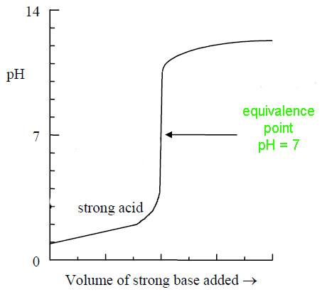 | 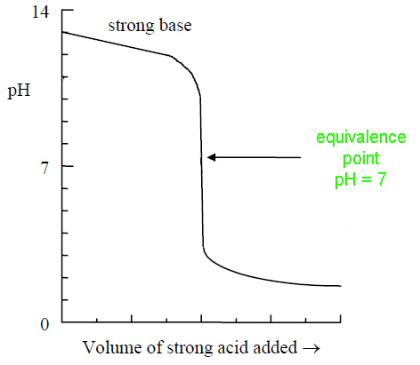
bromothymol blue 6.0 7.6 yellow blue

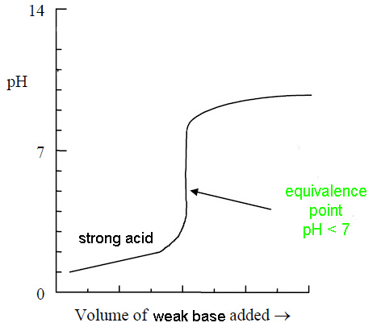  pKa  of conjugate acid  pKa  of  conjugate acid | 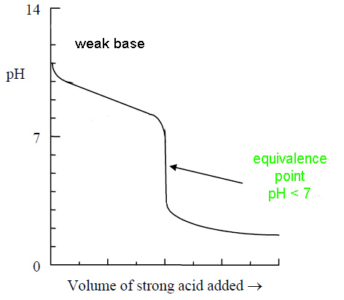
methyl orange 3.2 4.4 red yellow

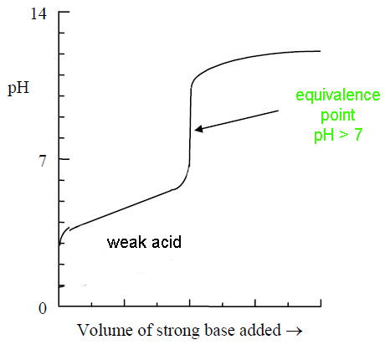  pKa | 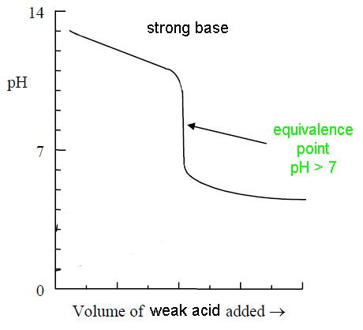  pKa
phenolpthalein 8.2 10.0 colourless pink
https://www.chemical-minds.com

