Predicting Entropy Change (Level 3) exam tips: Read these please!
Entropy, symbol S, is a measure of the level of disorder of a system.
An increase in disorder produces a positive ΔS value
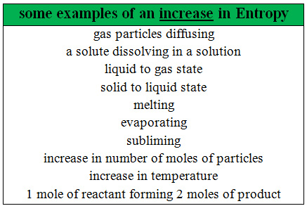

Also…”don’t be daft”
Think right back to basics, the particle theory that you learnt about in junior Science... is the particle
movement becoming more random and disorderly?
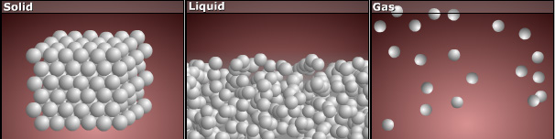

© 2018 https://www.chemical-minds.com

