Esters (Level 3) exam tips: Read these please!
When naming esters name the alcohol side first change the ending of the alcohol name to –yl
Then name the carboxylic acid side, change the ending of the acid name to –anoate

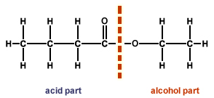
Note that, for Excellence, you must be able to write the hydrolysis equations of esters

Also…”don’t be daft”, what NOT to do
don't forget that the second product of an esterification reaction is water

© 2018 https://www.chemical-minds.com

