Isomers
Isomers are molecules that have the same molecular formula but different structural formula
1) Constitutional aka Structural
chain isomerism | positional isomerism | functional group isomerism
butane  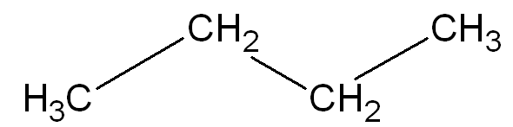 | 1-bromopropane  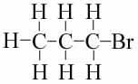 | propanoic acid  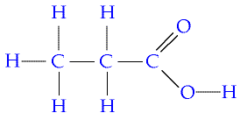
2 methyl propane  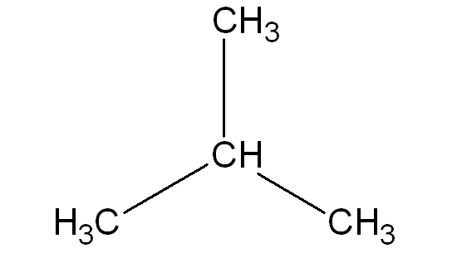 | 2-bromopropane  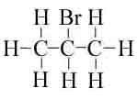 | methyl ethanoate  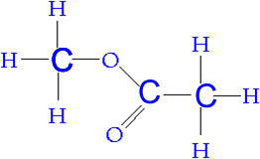
pentane C₅ H₁₂ has 3 isomers  make, draw & name them | make & draw butan-1-ol and butan-2-ol | C₂H₆O has 2 isomers  methoxy methane (an ether)  not required for NCEA Level 2 or 3  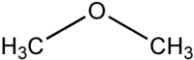  and

2) Stereoisomers
geometric cis or trans isomers | Enantiomers
cis-1,2-dichloroethene trans-1,2-dichloroethene  restricted rotation about a C=C  2 different groups on the left hand side  and 2 different groups on the right hand side | CBrClFI  are mirror images of each other  have the same structural formula  known as optical isomers because of their effect on plane polarised light  have 4 different groups positioned around a chiral carbon atom
make & draw cis-but-2-ene  and  trans-but-2-ene | make & draw 2 3d sketches of butan-2-ol  so that they are mirror images of each other
additional information  mp (‘C) bp (‘C)  cis -80 60  trans -50 48  why is the bp of cis higher?  cis is polar trans is non-polar with  permanent dipole forces as well as temporary dipole forces  so  more energy is required to boil the cis isomer so bp is higher  why is the melting point of cis lower?  in a solid state the molecules must pack together efficiently, however the U shape of the cis isomer will not pack as well as the straight shape of the trans isomer  so  less energy is needed to melt the cis isomer so the mp is lower | additional information  A solution of one enantiomer rotates the plane of polarisation in a clockwise direction. This enantiomer is known as the (+) form or given the letter L for levorotatory  A solution of the other enantiomer rotates the plane of polarisation in an anti-clockwise direction. This enantiomer is known as the (-) form or given the letter D for dextrorotatory  When optically active substances are made in the lab, they often occur as a 50/50 mixture of the two enantiomers. This is known as a racemic mixture or racemic. It has no effect on plane polarised light.

© 2018 https://www.chemical-minds.com

