Cracking (Level 1) exam tips

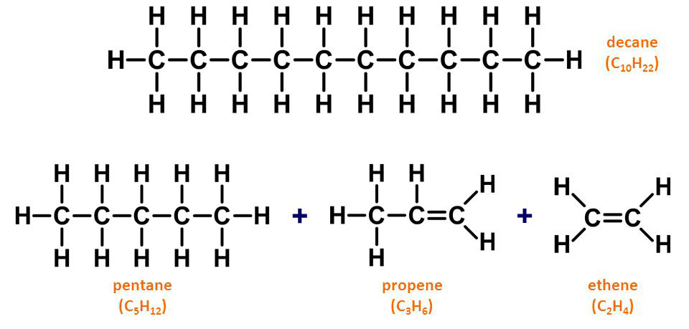
Cracking is the process of converting large (not so useful) molecules into smaller (much more useful molecules)

Cracking requires both a high temperature and high pressure (or a catalyst)

The products from cracking are usually used as fuels eg propene (BBQ gas), butene (camping gas) and ethene is used in the production of polymers (plastics)

Also…”don’t be daft”
no, no, no crude oil is NOT one large molecule

http://www.chemical-minds.com

