Properties and uses of Acids and Bases (Level 1) exam tips
Litmus paper has only two colours - red in acid and blue in base
Litmus paper doesn't change colour in a neutral solution; red litmus stays red and blue litmus stays blue
Be familiar with the different colours of universal indicator
Try to link the colour...with the pH number... with the ions... see image below
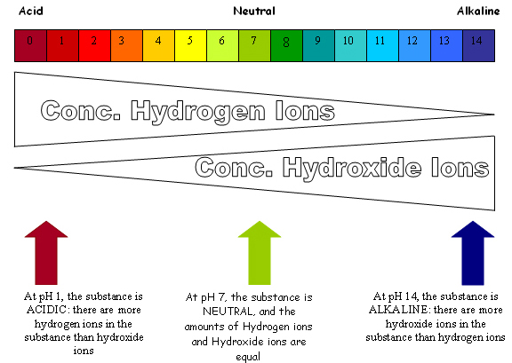
Learn the formulas of the 3 main laboratory acids...
Hydrochloric acid (aka hydrogen chloride) HCl
Sulfuric acid (aka hydrogen sulfate) H₂SO₄
Nitric acid (aka hydrogen nitrate) HNO₃
acid + base salt + water: this is a neutralisation reaction
acid + carbonate salt + water + carbon dioxide: this is also a neutralisation reaction
When writing balanced chemical equations always write the formula (use little subscript numbers) of
each substance BEFORE balancing the whole equation (with large numbers in front)
Water forms from H⁺ (hydrogen ions) from the acid joining with the hydroxide ions (OH⁻) from the base
 | "nitric acid, nitrate  sulfuric acid, sulfate  hydrochloric makes chlorides  they're the salts acids make"  to the tune of Happy Birthday | "carbonates make CO₂  and a salt, water too  carbonates make CO₂  with all acids"  to the tune of London Bridge
 | credit for the songs to Heather (AGGS)
Also…”don’t be daft”
HCl is HCl not hCl nor Hcl nor HCL
Sodium hydrogen carbonate (aka sodium bicarbonate) is a base
Litmus paper never, EVER turns green!
A neutral solution would have NO EFFECT on either red or blue litmus paper
RTQ² - read the question twice!
If asked to make a salt using sulfuric acid then do! don't write about another acid in your answer
Acid + base salt + water (NEVER, NOT EVER hydrogen)
Seeing BUBBLES is an OBSERVATION, a gas is formed is NOT
Check your balanced equations carefully...
Have you got the same NUMBER of atoms on the left (reactants) as on the right (products)
Attempt all questions, ALL and every part of each question

© http://www.chemical-minds.com

