Atomic Structure (Level 1) exam tips
Atomic number is the number of protons, which is the same as the number of electrons.
This is provided for you on the periodic table in your resource book.
If needed the mass number will be provided for you in the question.
Mass number: the number of protons PLUS neutrons in the nucleus of an atom.
Electrons are super light (1/1850) of the mass of protons and neutrons and orbit the nucleus in electron
shells so the number of electrons are NOT included in the Mass number.
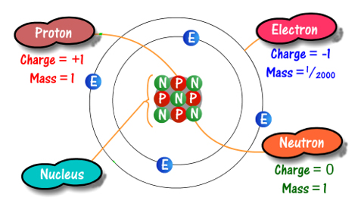
Atoms are neutral because they have the same number of protons (positive charge) and electrons
(negative charge).
When writing electron configuration remember 2 electrons in the first shell 8 in all the other shells.
In senior chemistry you will learn that there can be more than 8 electrons orbiting the nucleus of an atom.
Atoms in the same group (vertical columns) have the same number of outer/valence electrons.
Atoms in the same period (horizontal rows) have the same number of electron shells.
Atoms lose or gain electron(s) to form an ion which has a "STABLE FULL outer/valence shell".
eg a magnesium atom has 2 electrons in the outer shell, so would lose 2 electrons as less energy is
required for the magnesium atom to lose 2 electrons than would be required to gain 6 electrons.
An Ion is formed from an atom that has lost or gained electrons to form a stable full outer/valence shell
A CATion is a Positive ion (CATS Purr) and an Anion is a negative ion.
There's no need to learn the ionic symbols - recognise them from the ions table in your resource booklet.
Write down the number of negative electrons and number of positive protons of both atoms AND ions
Elements in the same group eg Group 1 all form ions with the same charge 1+.
An Ionic bond forms when electrons are transferred between atoms to form positive ion(s) and a
negative ion(s), there is a strong force of attraction between the oppositely charged ions.
Ionic compounds have no overall charge because the positive charge of the cation cancels out the
negative charge of the anion. The same number of electrons that have been lost by one (or more atoms),
have been gained (by one or more atoms).
When working out ionic formulae of an ionic compound, you can use "swap and drop", however don't
refer to that in your explanation.
Also…”don’t be daft”
Use your ions table in the resource booklet, recognise the formula and know the names of all of the ions.
SulfIDE ion is S²⁻ this is very, very different to the sulfATE ion SO₄ ²⁻.
Oxide ion is O²⁻ this is very, very different to the hydroxide ion OH⁻.
"SWAP and DROP", is meaningless, explain clearly how you cancelled the charges of the ions.
A full outer shell is STABLE – you absolutely must state this somewhere
It is never “easier” for atoms to lose or gain electrons, refer to less energy being required
Similarly, atoms are not “happier” etc with a full outer shell
Do not write that ionic compounds are “neutral”, it implies they have a pH of 7.
© http://www.chemical-minds.com

