Describing type of substances, particle and bonding (Level 2) examiners tips
Be logical here! look out for obvious ones first...
eg. diamond, graphite and silica or silicon dioxide are covalent network
eg metals are metallic bonding
eg metals bonded with non-metals are ionic
eg non-metals bonded to themselves are molecular substances
See the table below, a summary of the type of substances, particle and type of bonding/attractive force
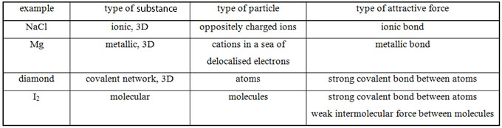
Also…”don’t be daft”
Please note that there is no such thing as a molecular bond, no such thing!
Be aware that it is not good enough to state electrostatic attraction as the type of attractive force
because all types of bonding are electrostatic attractions

© 2018 https://www.chemical-minds.com

