Explaining equilibrium (Level 2) exam tips
The Equilibrium Law
You must mention Le Chatalier's Principle (aka The Equilibrium Law)" When a change is made to a system at equilibrium, the system responds to reduce the effect of that change.”

Concentration
When the concentration of reactant decreases/it is removed, the equilibrium shifts to oppose the change by increasing the concentration of the reactant, equilibrium moves to the left (backwards) to replace the lost reactant.
When the concentration of a reactant increases/ more is added, the equilibrium shifts to oppose the change by decreasing the concentration of the reactant, equilibrium moves to the right (forwards) to use up the excess reactant.

Pressure
When the pressure increases (with a decrease in volume) the system responds and decreasing the
pressure, this occurs by favouring the reaction that produces fewer gas moles. Because there are
fewer gas particles hitting the sides of the container, there is less pressure.
For Excellence you must specific the exact number of moles of gas particles on each side.
Also, note that if there are the same number of gas particles on both sides of the reaction, then a
change in pressure will have no effect as neither reaction will be favoured.

Temperature
When the temperature INcreases the system responds and decreasing the temperature by shifting in the ENdothermic direction (think ENTRANCE)...because the endothermic side absorbs the heat energy.
The decreasing value of K_{c} indicates that the reaction is reactant-favoured, as the concentration of reactants is a denominator in the equilibrium constant expression to calculate K_{c}. The forward reaction must be exothermic.

Catalyst
A catalyst does not change the position of equilibrium as a catalyst increases the rate of both forward and reverse reactions.

A compromise
In industry, for economic reasons a compromise will be reached between percentage yield and the
rate of reaction eg too low a temperature means too slow a rate of reaction, whereas for an
exothermic reaction, too low a temperature means less product formed

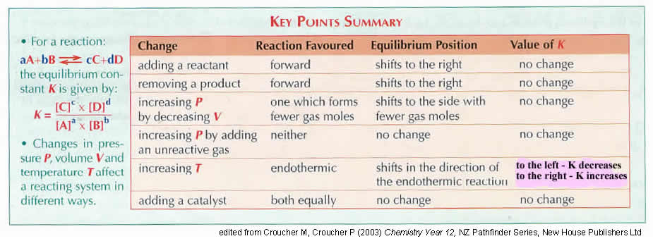

Also…don’t be daft!
Repeating this one… a temperature increase results in a reaction going to the ENDOthermic side (think ENTRANCE).... because the endothermic side ABSORBS the heat energy
A change to an equilibrium system NEVER "balances it out" nor adjusts it "50/50" nor "fights it back" but OPPOSES or MINIMISES the change
Answer the question that is being ASKED
Always name SUBSTANCES, state number of MOLES of particles etc...
Note that forward or backward reactions are endo/exothermic, reactants/products are not!

© https://www.chemical-minds.com

