Identifying types of substances (Level 2) exam tips.
Be logical here! look out for obvious ones first...
eg. diamond, graphite and silica or silicon dioxide are covalent network solids.
eg metals have metallic bonding.
eg metals bonded with non-metals are ionic substances.
eg non-metals bonded to themselves are molecular substances.
See the table below, a summary of the type of substances, particle and type of bonding/attractive force
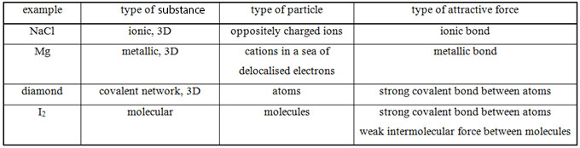
Don’t be daft.
Please note that there is no such thing as a molecular bond, no such thing!
Be careful, when describing metallic bonding, it is CATIONS (not atoms!) in a sea of electrons.
Be aware that it is not good enough to state electrostatic attraction as the type of attractive force
because all types of bonding are electrostatic attractions.

© https://www.chemical-minds.com

