Organic identifying (Level 2) exam tips
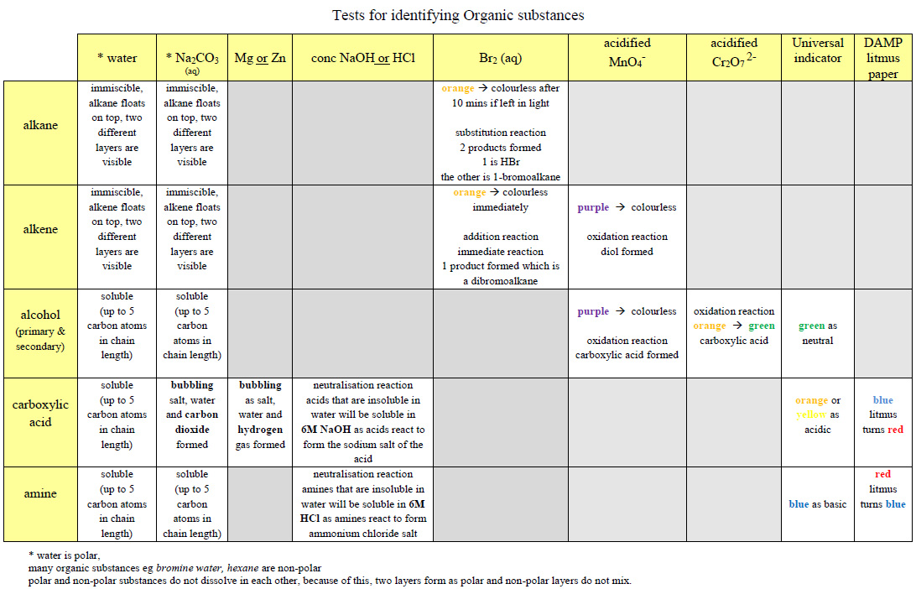
Also…”don’t be daft”
UV light has ABSOLUTELY NO effect on the reaction of acidified potassium permanganate (or dichromate) with an alkene
Never ever describe a colour as clear, write COLOURLESS
For colour changes always state the initial AND final colours
Litmus paper must be DAMP
Be careful the CORRECT formula for potassium permanganate is KMnO₄
Present your answers in a WELL STRUCTURED and ORGANISED manner

https://www.chemical-minds.com

