Major and minor products of addition reactions examiner’s tips
Markovnikov's rule is used to predict the major and minor products of an addition reaction of an asymmetric molecule onto an asymmetric alkene.

1. Look at the 2 carbon atoms on either side of the carbon to carbon double bond
2. Count the hydrogen atoms directly bonded to each of the carbon atoms, one of those carbon atoms has
more hydrogen atoms directly bonded to it, so, this is known as the "richer" carbon atom
3. Therefore the hydrogen from the hydrogen halide (or water) will more often bond onto this carbon
(which already contains the most hydrogen atoms) when the double bond breaks.
4. So, the eg halide from the hydrogen halide will bond onto the carbon atom in the double bond which has
the least number of hydrogen atoms already bonded onto it
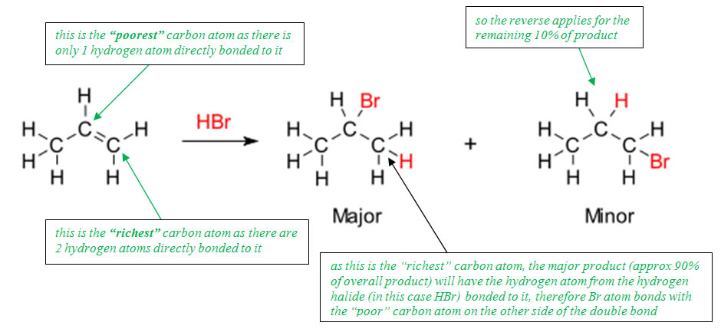

Structure your exam answer carefully
What type of reaction is this and why?
This is an addition reaction because the double bond is broken and two new atoms are added, a hydrogen and bromine atom.
Clearly, mention the word “asymmetric” when stating why there are two new products
There are two products because the alkene is asymmetric due to the position of the double bond.
Describe and explain formation of both the major…
There are two unique positions the H atom and Br atom can bond to, so there are two possible products.
The carbon atom of the double bond with the most hydrogen atoms attached gains another hydrogen atom in the major product. This means that 2- bromopropane will be the major product, since C1 has two hydrogen atoms and C2 has only one hydrogen atom; therefore C1 gains another H, forming 2-bromobutane.
and minor products
The carbon atom of the double bond with the most hydrogen atoms attached gains the bromine atom in the minor product. This means that 1-bromopropane will be the minor product, since C1 has two hydrogen atoms and C2 has only one hydrogen atom; therefore C1 gains a Br atom, forming 1-bromopropane.
Be sure to draw the structural formula and name the products

In more recent years, a statement has been required referring to situations when this rule does not apply and there is only one product. That is because the alkene is symmetrical due to the position of the double bond. The carbon atoms on either side of the double bond have the same number of hydrogen atoms attached.

Also…”don’t be daft”
"the rich get richer" means NOTHING! see explanation above and use something similar in your answers
Ensure you describe your reasons for formation of both “major” and “minor” products
https://www.chemical-minds.com

