Polymerisation (Level 2) examiners tips
To form a polymer (poly means many)
The double bond between the carbon atoms is broken and new single bonds form, the carbon bonds
from each monomer are able to bond to carbon atoms in other monomers forming a long chin polymer.
Remember the brackets and “n” indicating that the polymer can be any length or a wiggle line either end
of the polymer
Be careful when drawing polypropene, a common error is to form a polymer which is in fact polyethene!
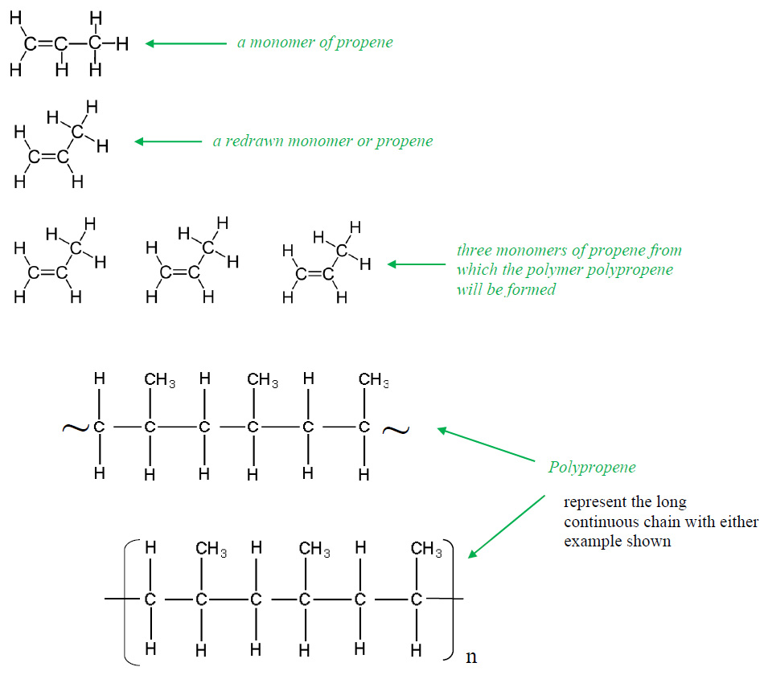

Also…”don’t be daft”
The monomer DOES have a DOUBLE bond between the carbon atoms
But don’t draw a carbon to carbon double bond in the POLYMER
Remember that every carbon atom must have FOUR bonds from it
Recall the conditions required from your Level 1 Chemistry: high temperature and high pressure with a
catalyst

https://www.chemical-minds.com

