Primary, secondary and tertiary haloalkanes and alcohols (Level 2) exam tips: Read these please!
Circle the carbon atom bonded to the functional group
look carefully..
if there is only 1 other carbon atom bonded to your circled carbon then, that is a PRIMARY molecule
if there are 2 carbon atoms bonded to your circled carbon then, that is a SECONDARY molecule
if there are 3 carbon atoms bonded to your circled carbon then, that is a TERTIARY molecule
It’s that easy!
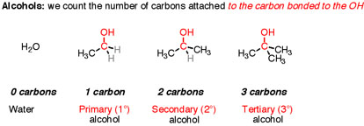
reference: masterorganicchemistry.com

© 2018 https://www.chemical-minds.com

