Structural Formula (Level 2) exam tips
Learn the functional groups, no excuses!
Every C atom must have 4 bonds from it
Draw neat diagrams of a sensible size
Remember to add in the hydrogen atoms
Be careful with the order in which you draw structural formula – see table below
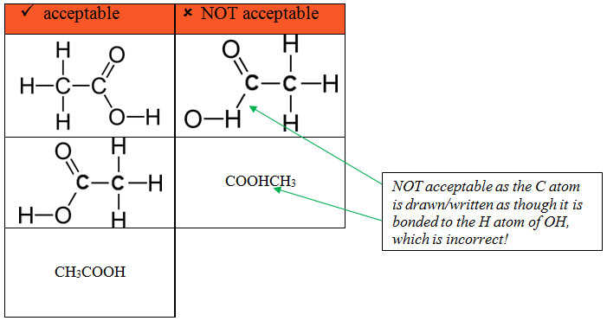

Also…”don’t be daft”
Don't forget to write in the H atoms in ALL of your diagrams
Count to FOUR, every carbon atom must have FOUR bonds from it

https://www.chemical-minds.com

