pH, H₃O⁺ and OH⁻ calculations (Level 2) exam tips

The following formulae will be provided to you in your exam on the resource booklet.
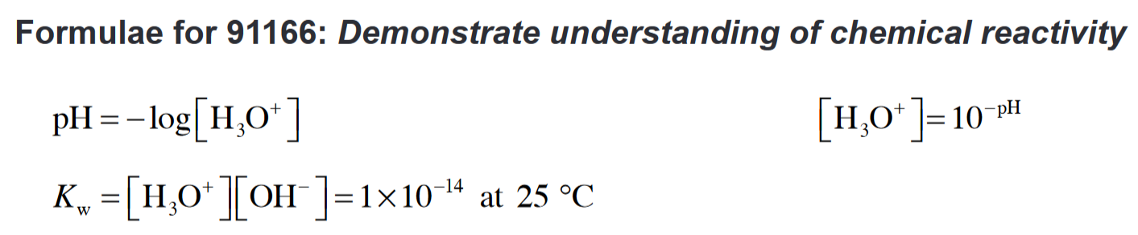
You must be familiar with inputting the data correctly into your calculator.
Always show your workings on paper in case you make an error.
Practise with your own calculator.
Finding the pH
pH = - log [H₃O⁺]
Finding the [H₃O⁺]
inv log - pH = [H₃O⁺]
Finding the [OH-]
Kw = [OH⁻]
[H₃O⁺]
Also…don’t be daft!
Do not round up till the end.
Be sure to give your answer to 3 significant figures.
You must include units; mol L⁻¹ for concentrations of H₃O⁺ and OH⁻.

© https://www.chemical-minds.com

