Polarity, bond dipoles, polar molecules and explaining polarity (Level 2) exam tips.
Polarity is the distribution of electrons around a molecule.
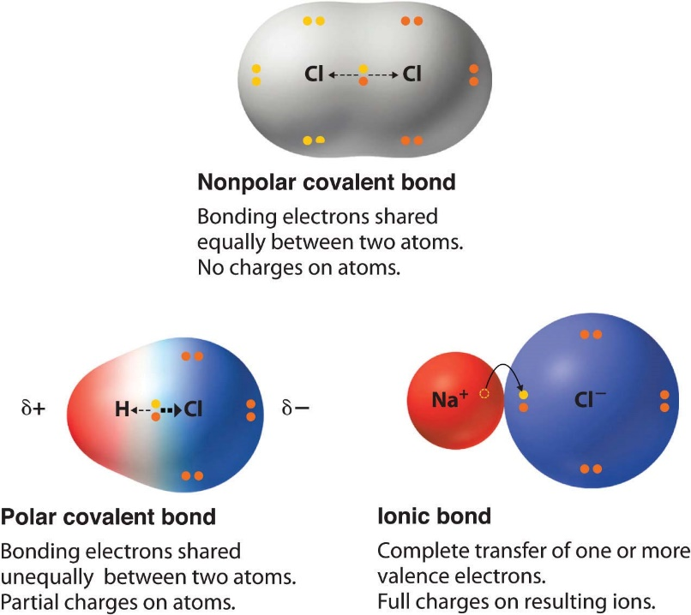
https://saylordotorg.github.io/text_general-chemistry-principles-patterns-and-applications-v1.0/s12-09-polar-covalent-bonds.html

Electronegativity is the measure of an atoms ability to attract electrons to itself.
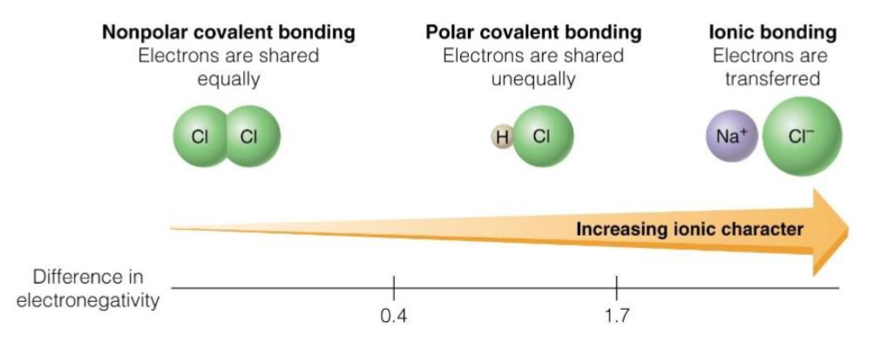
http://gzscienceclassonline.weebly.com/uploads/1/1/3/6/11360172/pdf_notes_chemistry_c2.4.pdf

Bond dipoles have a magnitude and direction. The symbols δ– and δ+ show the charges on a molecule.
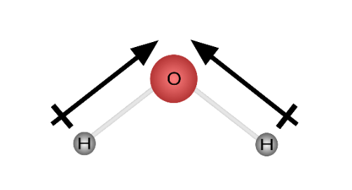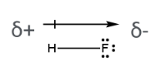
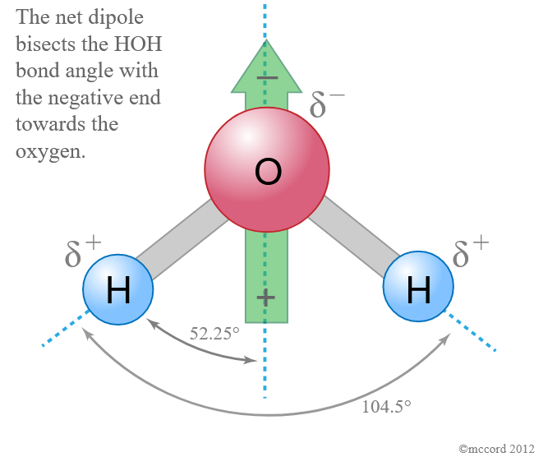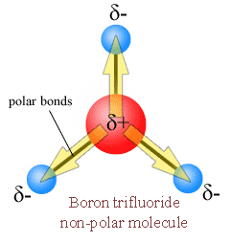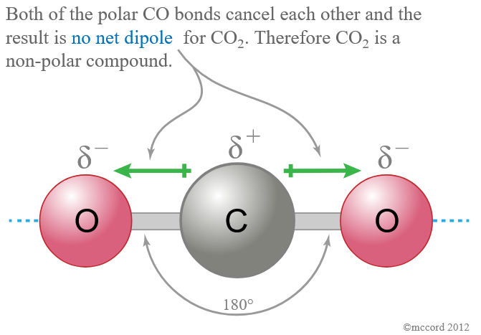
Explaining polarity
1st: State whether the molecule does or does not contain “polar bonds”.
If so, describe this in terms of the “difference in electronegativity” of the atoms in the molecule.
Note you do not need to recall electronegativity numbers, don’t waste your time learning them!
2nd: State the “shape” of the molecule, taking care to mention any lone pairs of electrons.
3rd: Describe whether the bond dipoles are “arranged symmetrically and cancel”
OR
“are arranged asymmetrically and do not cancel”.
Finally... An overall statement re polarity of the molecule.

To achieve with an Excellence, you must refer to the difference in electronegativity, bond polarity and symmetry.
If asked to compare or contrast be sure to use linking words such as also, as well as or however, whereas etc.

© https://www.chemical-minds.com

