Justifying properties of substances (Level 2) exam tips
Ensure you are familiar with the different types of substances.
Spend time familiarising yourself with the type of particle and attractive force in the different types of
substances ...then logically, the properties will fit into place and make sense.
Silica/silicon dioxide/SiO₂ is a covalent network substance and made up of 1 Si atom for every 2 O atoms
Click on the animation for microscopic visuals of NaCl dissolving in water
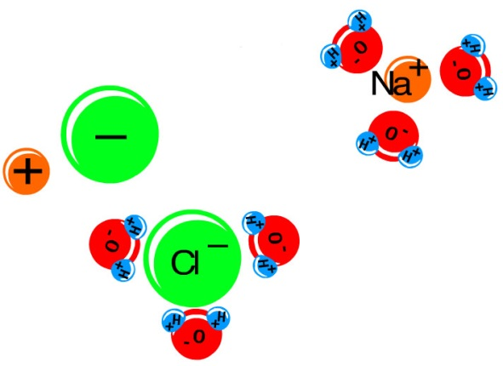
To achieve with Merit
You must be specific.
"strong covalent bonds between carbon atoms" as opposed to just "carbons.”
"strong ionic bonds between sodium cations and chloride anions" as opposed to "sodium and chlorides.”
If referring to substances dissolving in water, state "water molecules" not just water or molecules.
e.g. “ice melts because weak intermolecular forces are broken between water molecules.”
Usually electrons carry an electrical charge, in iionic substances, ions carry the electrical charge.
Metals are malleable because the bonds in metals are non-directional.
Ionic substances are NOT polar but are made up of positive (cation) and negative (anion) charges.

To achieve with Excellence
In some but not all years, students had to state that ionic, metallic and covalent network are 3D structures or in the case of graphite a 2D structure.
Discuss fully by linking the particle and strength force with the specific property.

Don’t be daft.
A covalent bond is a strong INTRAmolecular force between atoms INSIDE a molecule.
There is a weak INTERmolecular force which is BETWEEN different molecules.
An ionic substance is NEVER EVER described as being molecular nor polar.
Malleable: how a substance (usually a metal) can be BENT without snapping or breaking.
Ductile is a term used to describe STRETCHING a substance (usually a metal) into wires.
There are NO C atoms in silica/silicon dioxide/SiO_{2.}
Do NOT use a MEANINGLESS phrase… "like dissolves like" or "conductivity due to charged particles".
Refer to WATER MOLECULES not just water nor molecules.
Do not use BULLET points, you must discuss your answer in full sentences.

© https://www.chemical-minds.com

