Dipeptides, Tripeptides & Polypeptides (Level 3) exam tips

Glycine and alanine can combine together with the elimination of a molecule of water to produce a dipeptide – as shown below
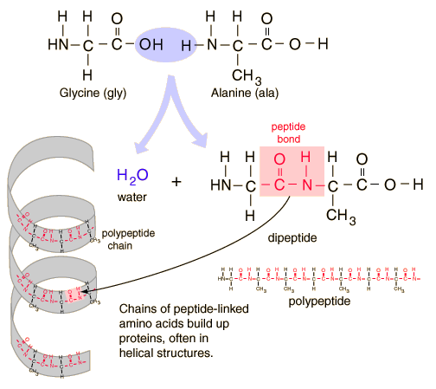
same as
Look carefully, you’ll notice that glycine and alanine can also combine to form a different dipeptide because the amino acids can join together and form an amide bond if the H is removed from the glycine and OH from the alanine to from a different dipeptide and a water molecule.

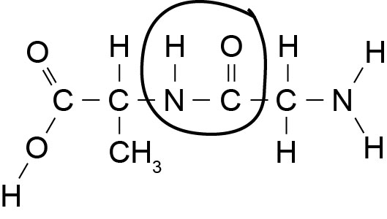 | 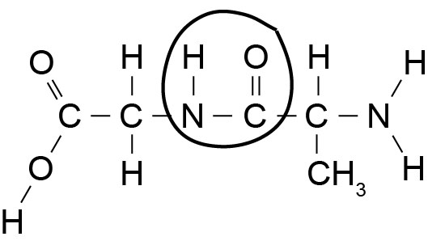
this dipeptide is exactly as the same as the one above, it’s just drawn back to front.

If three amino acids are joined together eg three molecules of glycine a tripeptide is formed.
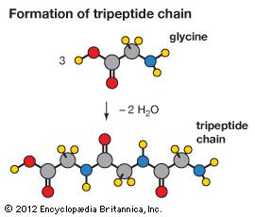
If lots of amino acids are joined together (as in a protein chain), a polypeptide is formed.

© 2018 https://www.chemical-minds.com

