Describing & explaining trends in atomic & ionic radii (Level 3) exam tips
Draw sketches and contrast sizes of atoms and ions sensibly.

Notice that an anion (negative ion) has a larger radius than its atom.
The Cl atom gains one electron to complete its valence shell to form the Cl– ion, the nuclear charge remains the same. The increased electron-electron repulsion in the outer energy level causes the valence electrons to move further from the nucleus, so the Cl– ion is larger than the Cl atom.

See below, graphs that summarise the trends in atomic and ionic radii
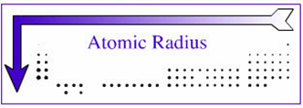
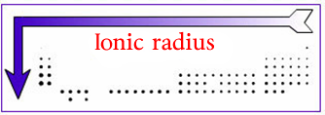
When discussing trends in atomic or ionic radii refer to
1. number of protons
2. attractive force of the nucleus/nuclear charge
3. loss or addition of electrons
4. number of energy levels
5. attraction to the valence electrons
You must refer to and link any similarity (or difference) to the elements asked about in the question.

The atomic radius decreases across a period.
There is an increase in the number of protons therefore the attractive force of the nucleus/ nuclear charge
increases. Electrons are added to the same energy level as well. This causes the electrostatic attraction between the positive nucleus and the valence electrons to increase across the period pulling the valence electrons closer to the nucleus, so the atomic radius decreases.

The atomic radius increases going down a group.
There is an increase in the number of protons therefore the attractive force of the nucleus/ nuclear charge
increases. However, going down a group, electrons are added to additional energy levels, which causes a decrease in the electrostatic attraction between the positive nucleus and the valence electrons. The valence electrons are further from the nucleus, so the atomic radius decreases.

Also…”don’t be daft”

A question asking you to compare and contrast means that different elements/atoms/ions must be discussed in DETAIL, not just the one element/atom/ion

Protons are never EVER, EVER!!!! lost when an atom forms an ion

When describing ionic radii, nuclear attraction on the outer shell electrons is NOT diluted, that's nonsense!

© https://www.chemical-minds.com

