Describing & explaining trends in electronegativity (Level 3) exam tips
Electronegativity is the ability of an atom to attract a bonding pair of electrons to itself.
Always relate the electronegativity of atoms within a molecule to
1. the polar/non-polar bonds within a molecule
and
2. to the overall shape of the molecule

See below a graph that summarises the trends in electronegativity across a period and down a group
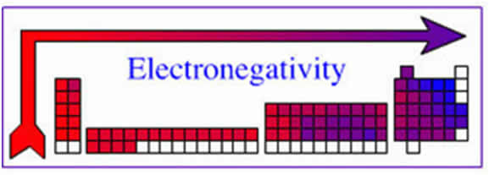
When discussing trends in electronegativity refer to
1. number of energy levels
2. shielding/electron-electron repulsion
3. number of protons/nuclear charge
4. attraction to the valence electrons
You must refer to and link any similarity (or difference) to the elements asked about in the question.

Electronegativity increases across a period
Elements in the same period have the same number of energy levels and therefore the same shielding/electron-electron repulsion from inner levels.
However, going across a period, non-metal elements (such as S) have more protons/greater nuclear charge and therefore a greater attraction for valence electrons than metallic elements in the same period (such as Na). Therefore, an element such as S has a greater electronegativity than Na.

Electronegativity decreases going down a group.
Doing down a group the energy levels increase, resulting in increased shielding/electron-electron repulsion. For example, sulfur has one more energy level than the oxygen atom and therefore increased shielding/electron-electron repulsion. Even though S has more protons/ greater nuclear charge than O because the valence electrons are further from the nucleus, the electronegativity of S is lower.

© https://www.chemical-minds.com

