Isomers (Level 3) exam tips: Read these please!

Practise drawing 3D diagrams of enantiomers
Be able to recall that enantiomers have a chiral carbon atom, meaning there are 4 different atoms or groups of atoms around the central carbon atom
and recall that enantiomers will rotate plane polarised light
either: x degrees to the left (levorotatory) or the mirror image: x degrees to the right (dextrorotatory)
Be careful when drawing enantiomers, the COOH may need to be drawn as HOOC, see the diagram below
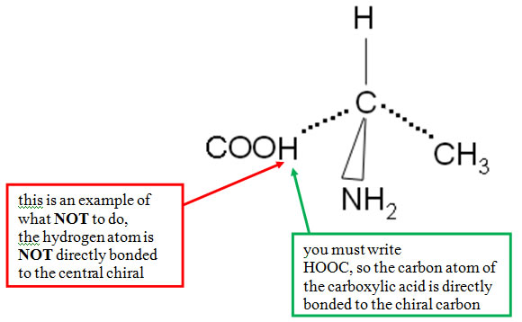
Also…”don’t be daft”
reflect, refract and ROTATE have very different meanings

© 2018 https://www.chemical-minds.com

