IUPAC (Level 3) exam tips

Commas between numbers
Hyphens between numbers and letters
Successive words merge into one
Pent- think of pentagon - a FIVE sided shape
Practise, practise, practise these!

Question: What is the correct IUPAC name of the organic molecule shown below?

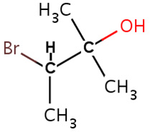
Click below for the answer and reasons for incorrect alternative IUPAC names

Also…”don’t be daft”
This is Level 3 Chemistry, you absolutely MUST be able to recognise the different FUNCTIONAL groups

© https://www.chemical-minds.com

