Major and minor products from an elimination reaction

2022

Compounds F and G both react with concentrated sulfuric acid, H₂SO₄(conc.) in an elimination reaction.

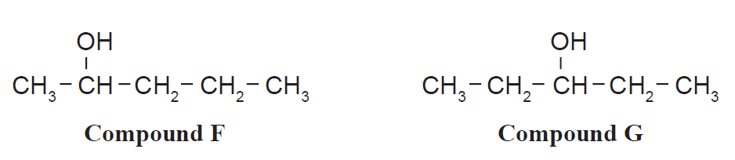
Compound F will produce two products, while Compound G will produce only one product.

(i) Give the structural formula of the product(s) for each elimination reaction.

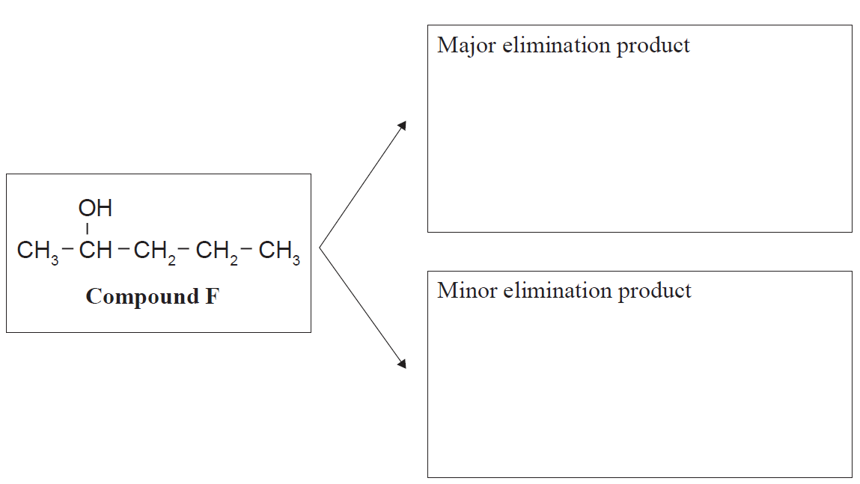

With reference to their structures, explain why Compound F produces two products, while Compound G
produces one product.

In your answer, you should justify any choice of major and minor products.

2019

Compare and contrast the reaction that forms compound B to the reverse reaction that forms propene, C3H6, from compound B.

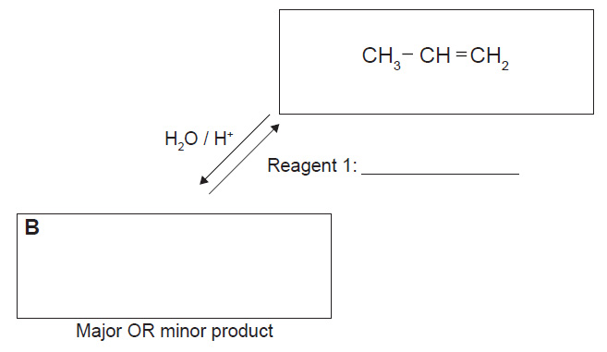

2018
Reacting 2-chloropropane with potassium hydroxide, KOH, can produce different products due to different
reactions occurring. Elaborate on the reactions of 2-chloropropane with potassium hydroxide, KOH.
In your answer you should:
- identify the conditions of the reagent KOH
- explain the types of reaction that occur with the reagent in each condition
- draw structural formulae of the organic products.

2017
2-bromo-3-methylbutane reacts with conc. KOH(alc). However, in this reaction TWO organic products
are formed, a major and a minor product.
Give an account of the chemical processes that occur in this reaction.
In your answer you should:
• write an equation for this reaction showing the organic compounds
• name the type of reaction occurring
• explain how the products form

• explain which product you would expect to be the minor product.

https://www.chemical-minds.com
NCEA questions and answers reproduced with permission from NZQA

