ANSWERS: **Major and minor products from an elimination reaction**

**2022**

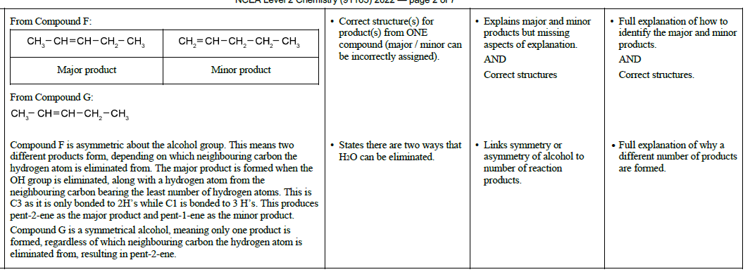

|  |  |  |  |  |
| --- | --- | --- | --- | --- |
| **2019** | **Evidence** | **Achievement** | **Merit** | **Excellence** |
|  | The reaction that forms compound **B** is an addition reaction where the double bond is broken to add OH and H to saturate the molecule  and form an alcohol.  The reverse reaction is the removal of the H and OH to form a double bond in an elimination reaction, forming an unsaturated molecule with a double bond. The elimination reaction uses concentrated sulfuric acid to remove the water whereas the addition reaction uses dilute sulfuric acid to add the water. The reactions are opposite in that one breaks the double bond to increase saturation and one forms a double bond to decrease saturation. | • States reaction to form **B** is addition.  • Reverse reaction is elimination. | • Explains the addition reaction*.*  • Explains the elimination  reaction. | • Contrasts the two reactions related to propene and propanol. |

|  |  |  |  |  |
| --- | --- | --- | --- | --- |
| **2018** | **Evidence** | **Achievement** | **Merit** | **Excellence** |
|  | A reaction with dilute aqueous KOH will produce an alcohol, propan-2-ol.    This is a substitution reaction. The Cl atom is substituted by an OH  group.  If concentrated KOH(*alc*) is used, an elimination reaction occurs, and the  2-chloropropane forms propene because a H and a Cl atom will be  removed, whilst a double bond is formed. | Identifies one product  (name or structure)  Identifies one type of reaction with correct reagent and product (can be in a structural formula). | Explains ONE type of reaction linked  to correct reagent condition and  organic product. | Elaborates on both  reactions of  2-chloropropane,  referring to reaction  type, conditions, and  products. |

|  |  |  |  |  |
| --- | --- | --- | --- | --- |
| **2017** | **Evidence** | **Achievement** | **Merit** | **Excellence** |
|  | In this elimination reaction, because 2-bromo-3-methylbutane is an asymmetric haloalkane, two organic products form. The Br atom is removed from the C2 atom, along with an H atom off an adjacent C atom, to form a C=C double bond. There are two H atoms that could be removed; one from the C1 atom or one from the C3 atom.  If an H is removed from the C1 atom, 3-methylbut-1-ene will form. If an H is removed from the C3 atom, then 3-methylbut-2-ene forms. Both products are formed, but there is more of one product than the other. These are called major and minor products.  To identify which is which (use ‘Saytzeff’s Rule’ or the ‘poor get poorer’), we look for the C atom adjacent to the C with Br attached, with the fewest H atoms attached initially, as this is the C atom that is most likely to lose another H atom. Resulting in 3- methylbut-2-ene being the major product and 3-methylbut-1-ene being the minor product. | Identifies ONE of the two organic products formed.  OR  Identifies the type of reaction. | Draws both products correctly and identifies the minor product. | Gives an account of the formation of the isomers and the relative concentrations of the organic products formed, i.e. major and minor products. |

<https://www.chemical-minds.com>

NCEA questions and answers reproduced with permission from NZQA