Is the structural diagram of the ester formed below Methyl butanoate or Butyl methanoate?

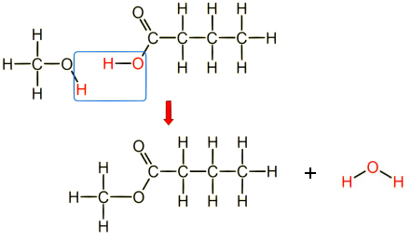
The carbonyl bond (C=O) indicates the carboxylic side of the ester ie butanoic acid
The single bond O indicates that the oxygen atom was from the alcohol ie methanol

When naming esters name the alcohol side first, change the name ending to –yl
ie methanol becomes Methyl
Then name the carboxylic acid side, change the name ending to –anoate
ie butanoic acid becomes butanoate

Answer: Methyl butanoate

© 2018 https://www.chemical-minds.com

