**Bond enthalpy**

**2022**

Freon-11, CCl3F(*g*), is produced in the lab by the reaction of carbon tetrachloride, CCl4(*g*), with

hydrogen fluoride, HF(*g*), as shown in the reaction below.

Use the change in enthalpy (Δr*H*°) for the reaction above and the bond energies listed in the table below to calculate the average bond energy of the C–Cl bond.

**2021**

Another fuel that can be used in rocket engines is methane, CH4(g).It reacts with oxygen, 02(g),as

shown by the reaction below.



Use the change in enthalpy (8.rH°) for the combustion of methane and the bond energies listed

in the table below to calculate the average bond energy of the C-H bond in methane.

**2020**

The chlorination of ethene can be shown by the following equation.



Calculate the bond enthalpy of the C – Cl bond using the data below.

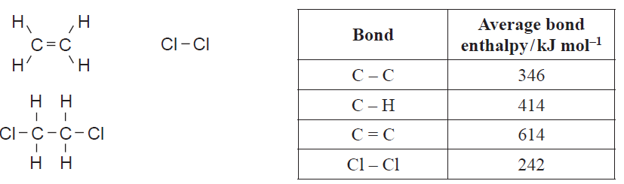

**2019**

When propane, C3H8(*g*), is burned, it reacts with oxygen, O2(*g*), in the air to form water, H2O(*g*), and carbon dioxide, CO2(*g*).



Calculate the average bond enthalpy of the C = O bond using the data below.



**2018**

Nitrogen gas, N2(*g*), reacts with hydrogen gas, H2(*g*), to produce ammonia gas, NH3(*g*), as shown by the

following equation



Calculate the average bond enthalpy of the **N–H** bond in NH3, using the average bond enthalpies in the table below.



**2017**

Hydrazine, N2H4, is used as rocket fuel.

Use calculations to determine which of **Reaction 1** or **Reaction 2** releases more energy.

**Reaction 1:** N2H4(*g*) + O2(*g*) → N2(*g*) + 2H2O(*g*)

**Reaction 2:** N2H4(*g*) + 2F2(*g*) → N2(*g*) + 4HF(*g*)

The structure of each chemical species is shown in the box below.



Use the average bond enthalpies given in the table below.



Show your working and include appropriate units in your answer.

**2016**

Calculate the enthalpy change, Δr*H*°, for the reaction of but-1-ene gas, C4H8(*g*), with hydrogen gas, H2(*g*),

to form butane gas, C4H10(*g*).

Use the average bond enthalpies given in the table below.

Show your working and include appropriate units in your answer.





**2015**

Ethene gas, C2H4(*g*), reacts with bromine gas, Br2(*g*), as shown in the equation below.



Calculate the enthalpy change, Δr*H*°, for the reaction between ethene and bromine gases, given the average

bond enthalpies in the table below.

Show your working and include appropriate units in your answer.



**2014**

Hydrogen gas, H2(*g*), reacts with oxygen gas, O2(*g*), as shown by the following equation

H2(*g*) + ½ O2(*g*) → H2O(*g*) Δr *H*° = –242 kJ mol–1

Given the average bond enthalpies in the table below, calculate the average bond enthalpy of the **O – H** bond in H2O.



**2013**

Chlorine reacts with methane to form chloromethane and hydrogen chloride, as shown in the equation

below.

CH4(*g*) + Cl2(*g*) → CH3Cl(*g*) + HCl(*g*)

Use the following bond enthalpies to calculate Δr *H*° for this reaction.



**2012**

(i) The equation for the combustion of propan-1-ol is:

CH3CH2CH2OH(*g*) + 4½O2(*g*) → 3CO2(*g*) + 4H2O(*g*) Δr*H* = –2 010 kJ mol–1

Calculate the bond enthalpy for the C=O bond, using the enthalpy of the reaction above and the bond enthalpy data in the table.

#### 

#### (ii) Define bond enthalpy and explain why the bond enthalpy value calculated for C=O is higher than the C–O bond enthalpy.

#### 2011

Complete combustion of methanol can be represented by the following chemical equation:

2CH3OH(*g*) + 3O2(*g*) → 2CO2(*g*) + 4H2O(*g*)

#### Use the following bond enthalpies to calculate Δr*H* for this reaction.

#### 

### 2010

The equation for the combustion of ethanol is:

CH3CH2OH(*g*) + 3O2(*g*) → 2CO2(*g*) + 3H2O(*g*) Δr*H*° = –1379 kJ mol–1

### Calculate the bond enthalpy for the O–H bond using the enthalpy of the reaction above and the bond enthalpy data in the table.

### 

### 2009

Calculate the enthalpy change for the reaction below using the bond enthalpy data in the table.

### CH3Cl(*g*) + NH3(*g*) → CH3NH2(*g*) + HCl(*g*)

### 

### 2008

### Methylhydrazine, N2H3CH3, can be used as a fuel.

### 

### (i) Define the term bond enthalpy.

### (ii) Use the bond enthalpies given in the table below to calculate the energy released when one mole of methylhydrazine vapour is burned.

### N2H3CH3(*g*) + 2½O2(*g*) → CO2(*g*) + N2(*g*) + 3H2O(*g*)

### 

### © <https://www.chemical-minds.com>

NCEA questions and answers reproduced with permission from NZQA­