Esters and triglycerides

**2019**

Triglycerides are found in fats and oils. Below is an example of a triglyceride.



(i) Put a circle around ONE of the ester groups in the triglyceride molecule shown above.

(ii) Compare and contrast the acidic and basic hydrolysis of the triglyceride molecule shown above

In your answer, you should include:

• an explanation of the hydrolysis reaction

• structural formulae of the products formed from both acidic and basic hydrolysis

• reagents and conditions required.

**2018**

Many organic synthesis reactions are heated under reflux.

(i) In the box below, draw the structural formula and name the ester formed from heating ethanol and butanoic acid under reflux in the presence of concentrated sulfuric acid.



(ii) From the diagrams below, give the number of the apparatus used for heating under reflux.



(iii) Outline the advantages of heating under reflux in the preparation of the ester in part (i).

(iv) From the diagrams above, give the number of the apparatus and explain the process that could be used to purify (separate) the ester in part (i) from the reaction mixture.

**2016**

A triglyceride found in olive oil has the following structure:



(i) Put a **circle** around one of the ester groups in the triglyceride molecule shown above.

(ii) Draw the structural formulae of the products produced by the hydrolysis of this triglyceride in basic conditions, using aqueous sodium hydroxide, NaOH.

**2015**

A triglyceride has the following structure:

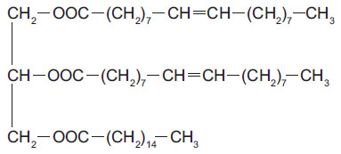

(i) Circle one of the alkene groups in the triglyceride molecule.

(ii) This triglyceride is described as unsaturated. Describe a chemical test that can be used to show that

the molecule is unsaturated. Give any observations, and state the type of reaction occurring.

(iii) Draw the structural formulae of the organic products formed by hydrolysis of this triglyceride using

aqueous sodium hydroxide.

**2014**

The triglyceride below is shown in condensed form.

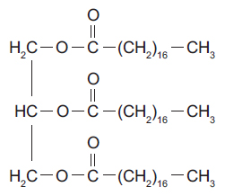

(i) Circle a functional group on the diagram above and give its name.

(ii) Compare and contrast the reaction of the above triglyceride when it undergoes both acidic and basic

hydrolysis. In your answer you should include:

• drawings of condensed structures of the organic products

• any reagents and conditions required for the reaction to proceed.

**2013**

Give the structures and names of the products of the reactions below.

These reactions are carried out by heating in either:

• dilute hydrochloric acid solution, or

• dilute sodium hydroxide solution.

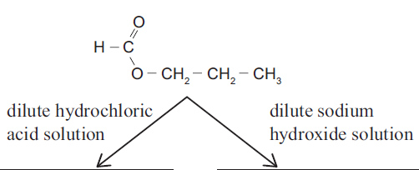

© <https://www.chemical-minds.com>

NCEA questions and answers reproduced with permission from NZQA