**Polymers**

**2022**

Ethene is a hydrocarbon that can be used as a monomer to produce polythene (polyethene).

(i) Draw at least TWO repeating units of polythene.

(ii) Explain why ethane cannot be used to produce polythene, while ethene can.

**2021 (edited)**

(i) Draw the structural formula of the monomer that makes propene

(ii) Name the type of reactions AND the conditions required

(ii) Draw the polymer propene *(suggestion of 3 monomers, unless otherwise told in the question)*

**2020**

Three hydrocarbons are ethene, propene and propane.

(i) Draw the structural formulae of ethene, propene and propane in the boxes below.



(ii) Why can polymers be made from ethene and propene, but not from propane?

In your answer, you should:

• describe how the polymers are made from ethene or propene, including any conditions required

• refer to the structures of the different hydrocarbons.

(iii) In the box below, draw TWO repeating units of the polymer made from **propene**.

Plastic bags can be made of the polymer polyethene. Supermarkets in New Zealand no longer give out these

bags. Explain why polyethene is useful for making plastic bags, and why they are no longer given out in

supermarkets.

In your answer, you must refer to the physical and / or chemical properties of polyethene.

**2019**

(a) How do molecules of ethene form polyethene?

In your answer, you should refer to the structures of ethene and polyethene and draw a section of polyethene

containing FOUR repeating units.

(b) Polyethene is a type of plastic. Plastics are used to make many different things.

Complete the table below, giving two uses of plastics linked to the properties that are important for these uses.

|  |  |
| --- | --- |
| **Use** | **Property / properties that are important for this use** |
|  |  |
|  |  |

**2018**

Polymerisation reactions are used to make the commonly used polymer, polyethene.

(i) What is the name of the monomer unit that polyethene is made from?

(ii) Elaborate on the polymerisation reaction involved in producing polyethene.

In your answer you should:

• refer to the structure of the monomer unit

• state any conditions required for the reaction, and explain why they are needed

• give the structural formula of polyethene.

**2017**

Explain why **propene** can be used to make polymers, but **propane** cannot. In your answer, you should explain

the chemical reaction that occurs between propene molecules to form the polymer, polypropene.

**2016**

Octane can be used to produce the polymer, polyethene. Octane undergoes Reaction 1 to form hexane and

Product 2. Product 2 can be used to produce polyethene.

(i) Complete the reaction scheme by filling in the boxes to show all structural formulae, as well as the name for Product 2.

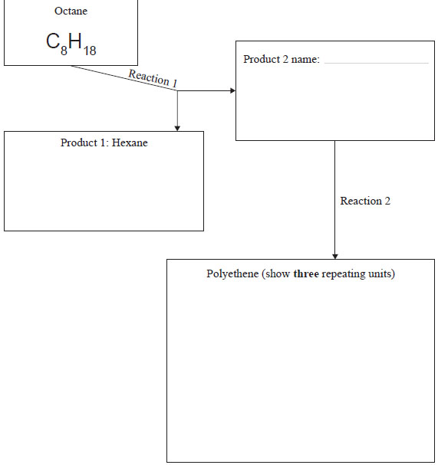

(ii) Elaborate on Reaction 1 and Reaction 2. In your answer, you should:

• name the types of reactions occurring

• give the conditions required for each reaction

• explain how polyethene can be made from Product 2.

© <https://www.chemical-minds.com>

NCEA questions and answers reproduced with permission from NZQA