Cracking

2019
(i) What is the name of the process to break down large molecules from crude oil into smaller hydrocarbon molecules and why is it necessary for the production of polymers?
(ii) Write a balanced symbol equation to show heptane being broken down into pentane and ethene.
(iii) Write a balanced symbol equation to show the products formed when C₁₅H₃₂ is broken down into the smaller hydrocarbon molecules of octane, ethene, and propene.

2018
Balanced symbol equation for the cracking of hexane to form ethene

2017
(i) Write a balanced symbol equation for the cracking of decane, C₁₀H₂₂, to produce pentane and two other products.

(ii) Contrast the processes of fractional distillation and cracking.
In your answer, you should refer to relevant physical and / or chemical properties of hydrocarbons.

2016
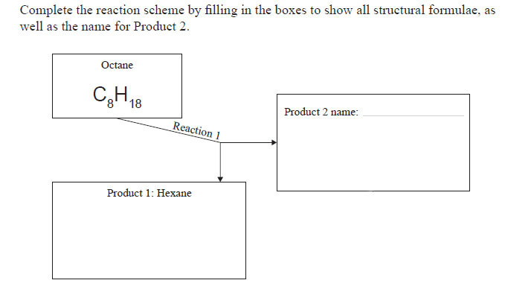

2015
Dodecane, C₁₂H₂₆, can be reacted in to form ethene and octane.
(i) State one condition that is needed.
(ii) Write a balanced symbol equation for the cracking of dodecane.

© https://www.chemical-minds.com
NCEA questions and answers reproduced with permission from NZQA

