**Enthalpy change calculations**

**2022**

**(a)**

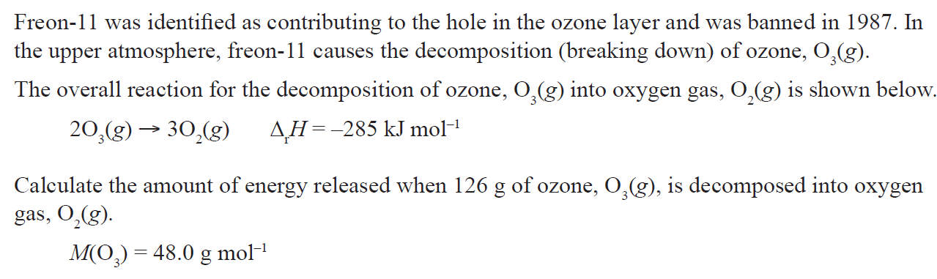

**(b)**

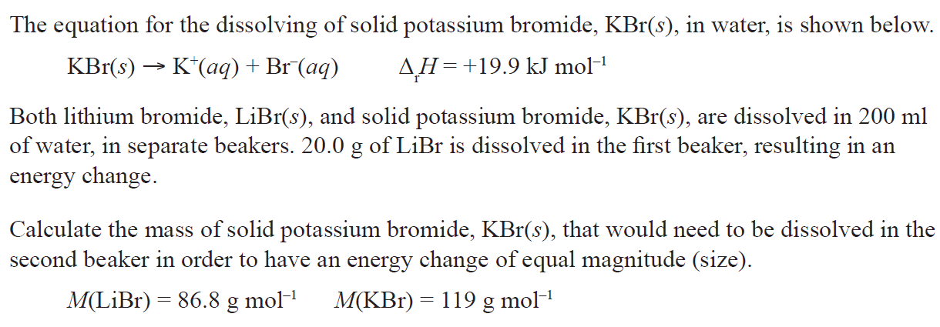

**2021**

**(a)**

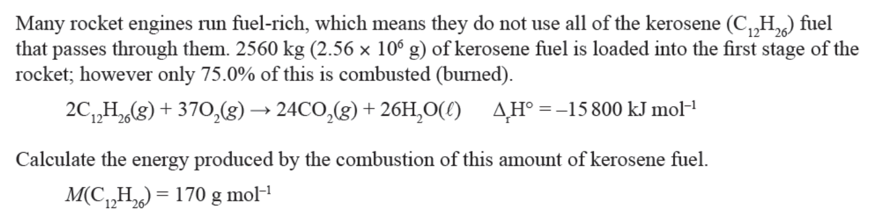

**(b)**

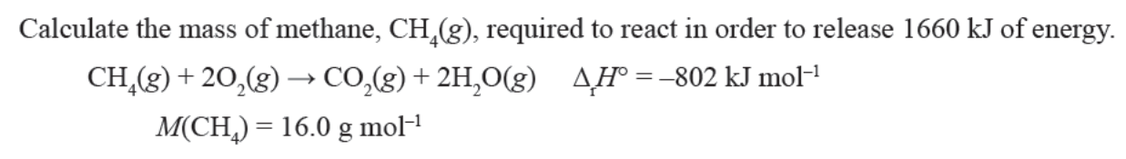

**2020**

**(a)**

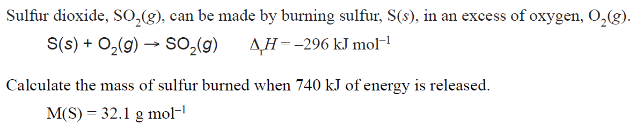

(b)

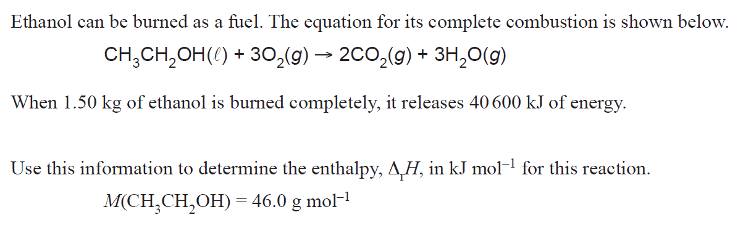

**2019**

(a) When magnesium, Mg(*s*), is burned, it produces a white powder according to the equation below.



(i) Calculate the mass of oxygen required to produce 1804.5 kJ of energy.

*M*(O) = 16.0 g mol–1

(ii) Calculate the energy change when 100 g of MgO(*s*) is produced.

*M*(MgO) = 40.3 g mol–1

**(b)** A common industrial process is the extraction of metals from their ores. Aluminium is found naturally

in aluminium oxide, and the oxygen is removed to produce the metal.

Information is given below of the enthalpy change when aluminium, Al(*s*), is extracted.



A production plant produces 65.0 kg (65 000 g) of aluminium per minute. Calculate how much energy is required per hour of production of aluminium. Round your answer to 3 significant figures.

*M*(Al) = 27.0 g mol–1

**2018**

The following is the equation for the combustion of butane gas in oxygen.



The fuel cylinder for the stove contains 450 g of butane gas.

Calculate the energy released when this mass of butane gas is burned completely in oxygen.

Show your working and include appropriate units in your answer.

*M*(C4H10) = 58.0 g mol–1

**2017**

Thermite reactions occur when a metal oxide reacts with a metal powder.

The equations for two thermite reactions are given below:

**Reaction 1:** Fe2O3(*s*) + 2Al(*s*) → 2Fe(*s*) + Al2O3(*s*) Δ**r***H*° = –852 kJ mol–1

**Reaction 2:** 3CuO(*s*) + 2Al(*s*) → 3Cu(*s*) + Al2O3(*s*) Δ**r***H*° = –1520 kJ mol–1

Use calculations to determine which metal oxide, iron(III) oxide, Fe2O3(*s*), or copper(II) oxide, CuO(*s*),

will produce more heat energy when 50.0 g of each metal oxide is reacted with aluminium powder, Al(*s*).

*M*(Fe2O3) = 160 g mol–1 *M*(CuO) = 79.6 g mol–1

**2016**

Hexane, C6H14 and pentane, C5H12 will combust (burn) in sufficient oxygen to produce carbon dioxide gas and

water.

Pentane combustion C5H12(l) + 8O2(*g*) → 5CO2(*g*) + 6H2O(l) Δr*H* º = −3509 kJ mol–1

Hexane combustion: 2C6H14(l) + 19O2(*g*) → 12CO2(*g*) + 14H2O(l) Δr*H* º = −8316 kJ mol–1

Justify which alkane – pentane or hexane – will produce more heat energy when 125 g of each fuel is combusted in sufficient oxygen.

*M*(C5H12) = 72.0 g mol–1 *M*(C6H14) = 86.0 g mol–1

**2015**

Glucose is made in plants during photosynthesis when carbon dioxide gas, CO2(*g*), and water, H2O(l), react to produce glucose, C6H12O6(*aq*), and oxygen gas, O2(*g*). The photosynthesis reaction can be represented by the following equation:

6CO2(*g*) + 6H2O(l) → C6H12O6(*aq*) + 6O2(*g*) Δr*H*° = 2803 kJ mol–1

Calculate how much energy is absorbed or released in the photosynthesis reaction if 19.8 g of carbon dioxide gas, CO2(*g*), reacts completely with excess water, H2O(l), to form glucose, C6H12O6(*aq*), and oxygen gas, O2(*g*).

Show your working and include appropriate units in your answer.

*M*(CO2) = 44.0 g mol–1

**2014**

Methanol and ethanol can both be used as fuels. Their combustion reactions can be represented by the

following equations:

Methanol combustion: 2CH3OH + 3O2 → 2CO2 + 4H2O Δr *H*° = –1450 kJ mol–1

Ethanol combustion: C2H5OH + 3O2 → 2CO2 + 3H2O Δr *H*° = –1370 kJ mol–1

Justify which fuel, methanol or ethanol, will produce more heat energy when 345 g of each fuel is

combusted in excess oxygen.

*M*(CH3OH) = 32.0 g mol–1

*M*(C2H5OH) = 46.0 g mol–1

**2013**

1. Glucose is an important source of energy in our diet. The equation below shows the combustion of

glucose to form carbon dioxide and water.

C6H12O6(*s*) + 6O2(*g*) → 6CO2(*g*) + 6H2O(*ℓ*) Δr *H°* = *–*2 820 kJ mol–1

Females who are moderately active need 9 800 kJ of energy per day.

Calculate the number of moles of glucose that would provide this daily energy requirement.

2. The equation below shows the combustion of butane.

C4H10(*g*) + 13/2 O2(*g*) → 4CO2(*g*) + 5H2O(*g*)

When 100 g of butane undergoes combustion, 4 960 kJ of energy is released.

Calculate the enthalpy change when 1 mole of butane undergoes combustion.

*M*(C4H10) = 58.1 g mol–1.

3. The iron oxides Fe3O4 and Fe2O3 react with aluminium as shown below.

3Fe3O4(*s*) + 8Al(*s*) → 4Al2O3(*s*) + 9Fe(*s*) Δr *H*° *= –*3 348 kJ mol–1

Fe2O3(*s*) + 2Al(*s*) → Al2O3(*s*) + 2Fe(*s*) Δr *H*° *= –*851 kJ mol–1

Justify which iron oxide, Fe3O4 or Fe2O3, will produce more heat energy when 2.00 kg of iron is formed

during the reaction with aluminium.

Your answer should include calculations of the heat energy produced for the given mass of iron formed.

*M*(Fe) = 55.9 g mol–1.

### © <https://www.chemical-minds.com>

NCEA questions and answers reproduced with permission from NZQA­