Describing and explaining shapes of molecules

When justifying shapes of molecules you must refer to

~ electron repulsion, “the electron clouds maximise separation to minimise repulsion”

~ regions of negative charge around the central atom (just to be sure, name that central atom)

~ number of bonding as well as non-bonding electron pairs.

**2023**

The Lewis diagram for ethanol is shown below.

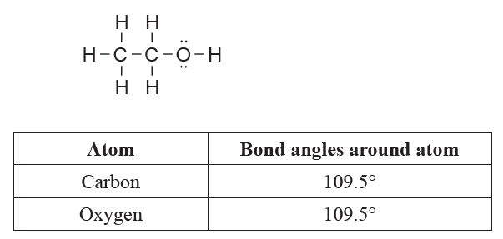

Compare and contrast the shape and bond angles around the carbon and oxygen atoms in ethanol, with

reference to VSEPR theory.

**2022**

Chlorofluorocarbons (CFCs) were molecules commonly used as refrigerants in the 1970s and 1980s. One

such example is trichlorofluoromethane, CCl3F, commonly referred to as freon-11. It is shown in the table

below, with another refrigerant, SO2.

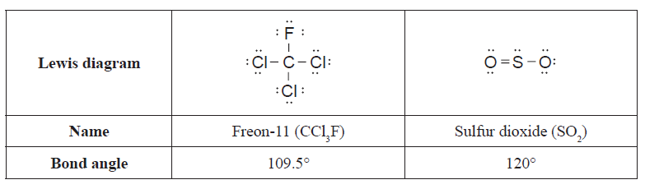

Compare and contrast the shape and bond angles of freon-11 with SO2.

**2021**

The Lewis diagrams and bond angels of two different propellants that have been used in rocket engines are

shown below.



Explain the difference between the shapes and bond angles about the nitrogen atoms that are coloured red in

each molecule.

**2020**

CH2O and NF3 have the same number of atoms in their formulae, but have different shapes and bond angles.

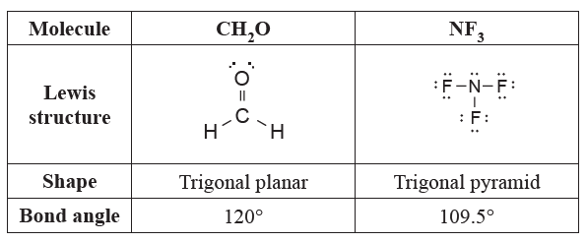

Justify the shapes and bond angles of CH2O and NF3.

**2019**

The molecules CH4, NCl3 and OF2 have different shapes; however each molecule has an approximate bond

angle of 109.5°. Justify this statement by referring to the factors that determine the shape of each molecule.

**2018**

Compare and contrast the shapes and bond angles of NH3 and BF3.

**2017**

Names the shapes and justify the shapes and bond angles of HOCl and COCl2.





**2016**

(a) Carbon (graphite) conducts electricity when it is solid, whereas zinc chloride, ZnCl2, will not conduct

electricity when solid, but will conduct when molten.

Justify this statement in terms of the particles, structure, and bonding for both substances.

(b) Solid zinc chloride, ZnCl2(*s*), is soluble in water. Dry ice, CO2(*s*), is not readily soluble in water.

Justify these statements in terms of the particles, structure, and bonding of these substances.

You may include a diagram or diagrams in your answer.

**2015**

Carbon atoms can bond with different atoms to form many different compounds.

The following table shows the Lewis structure for two molecules containing carbon as the central atom,

CCl4 and COCl2. These molecules have different bond angles and shapes.



Evaluate the Lewis structure of each molecule to determine why they have different bond angles and shapes.

In your answer, you should include:

• the approximate bond angle in each molecule

• the shape of each molecule

• factors that determine the shape and bond angle for each molecule.

**2014**

The Lewis structure for a molecule containing atoms of boron, oxygen, and hydrogen, is shown below.

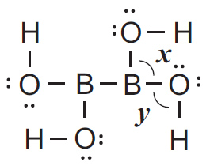

i) The following table describes the shapes around two of the atoms in the molecule above.

Complete the table with the approximate bond angles ***x*** and ***y***.

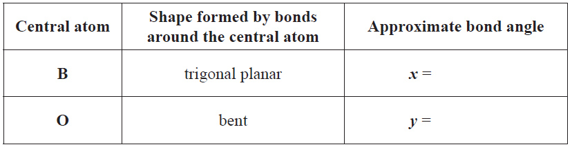

ii) The bond angles *x* and *y* in the molecule above are different. Elaborate on why the bond angles are

different. In your answer you should include:

• factors which determine the shape around the:

- B atom for bond angle *x and*  - O atom for bond angle *y*

• reference to the arrangement of electrons around the B and O atoms.

**2013**

Boron and phosphorus both bond with three fluorine atoms to form BF3 and PF3. However, the

molecules have different shapes and bond angles. The following table shows the Lewis structures for the

molecules BF3 and PF3.

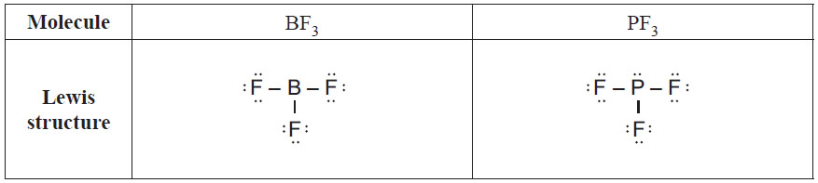

Explain why these molecules have different shapes and bond angles. In your answer include:

• the shapes of BF3 and PF3

• factors that determine the shape of each molecule

• the approximate bond angle in BF3 and PF3

• justification of your chosen bond angles for each molecule.

**2012**

The following table shows the Lewis structures and bond angles for the molecules SO2 and H2CO.



Explain why these molecules have different shapes but have the same approximate bond angle.

In your answer you should include:

• the shapes of SO2 and H2CO

• factors which determine the shape of each molecule

• an explanation of why the approximate bond angle is the same by referring to the arrangement of electrons

for each molecule.

© <https://www.chemical-minds.com>