**NCEA past examination questions on amino acids, dipeptides, polypeptides**

**2017**

Peptides are molecules that form when amino acids combine.

The following structures show the amino acids cysteine and serine.



(a) (i) In the boxes below, show two possible dipeptides that can be formed by combining the two amino acids shown above.

(ii) Circle the amide functional group on ONE of the dipeptides drawn in part (i).

**2016**

Glycine, alanine, and serine are three amino acids shown below.



(i) Draw the 3-D structures of the enantiomers (optical isomers) of **serine** in the boxes below.

(ii) Circle the amino acid which does NOT display optical isomerism. Explain your answer.

(iii) Draw the two possible dipeptides formed from the amino acids **glycine** and **alanine**.

(iv) Name the type of reaction that occurred when the dipeptides formed in (iii) above. Explain your choice.

(v) Draw the products of an acidic hydrolysis for ONE of the dipeptides from (iii) above.

Explain why these products are formed.

**2015**

Alanine is an amino acid. Its structure is shown below.



Draw 3-D structures of the enantiomers of alanine.

**2013**

Peptides are formed when amino acids combine.

(i) In the boxes below, show two possible dipeptides that can be formed by combining the amino acids:



(ii) Circle the amide link in each dipeptide.

**2013 Sample Exam**

1. Glycine and serine are two amino acids, which can combine to form dipeptides.

|  |  |
| --- | --- |
| **Chemistry 3**  **glycine** | Chemistry 3  **serine** |

1. Draw the structure(s) of the possible dipeptide(s) formed from a combination of glycine and serine.
2. Explain your answer in terms of the structure and functional groups present in the amino acids and in

the dipeptide(s).

1. Determine the products of hydrolysis of the molecule shown below in BOTH acidic and basic conditions.

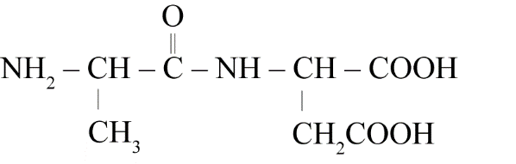

Justify your answer in terms of structure and reactivity.

**2008**

Amino acids are the building blocks that make up proteins. Alanine and valine are amino acids which can combine to form dipeptides.



(a) Draw the structure of a possible dipeptide formed from the combination of alanine and valine.

(b) Complete the following reaction scheme to show the organic products of the hydrolysis of the dipeptide

below using :

(i) dilute hydrochloric acid solution

(ii) dilute sodium hydroxide solution.



© 2018 <https://www.chemical-minds.com>

NCEA questions and answers reproduced with permission from NZQA