**Atomic and Ionic Radii**

**2022**

Explain why the radii of the Cl atom and the Cl– ion are different.

Radius of Cl atom = 99 pm Radius of Cl– ion =181 pm

**2021**

Explain the difference in the atomic radii of calcium and selenium.

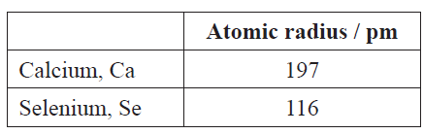

**2020**

Explain why the radii of the Mg atom and the Mg2+ ion are different.

**2019**

Explain why the radii of the S atom and the S2– ion are different.



**2016**

Explain why the radius of the Cl atom and the radius of the Cl– ion are different.



**2014**

Explain the difference between the radii of the K atom and the K+ ion.

**2013**

**Discuss the data for the following**



**2012**

Match the atoms and ions in the table below to the given radii **Radii:** 77 pm 123 pm 128 pm

Justify your answer.



**2011**

State which has the larger radius, Al or Al3+ . Justify your answer.

© <https://www.chemical-minds.com>

NCEA questions and answers reproduced with permission from NZQA