Solubility of solids in solutions forming a complex ion

2018
Explain the effect of the following on the solubility of iron(III) hydroxide, Fe(OH)₃, in water if potassium
thiocyanate, KSCN, solution is added.
Include relevant equation(s) in your answer. No calculations are necessary.

2013
In an experiment, 0.0100 g of Ag₂CrO₄ in beaker A was made up to a volume of 50.0 mL with
water. In beaker B, 0.0100 g of Ag₂CrO₄ was made up to a volume of 50.0 mL with 0.100 mol L^{–1} ammonia solution.
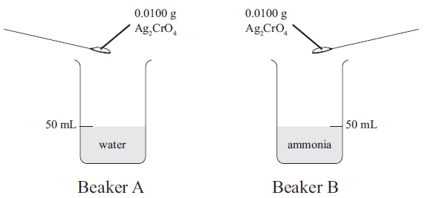
Compare and contrast the solubility of Ag₂CrO₄ in beaker A and beaker B. No calculations are necessary.

2011
A saturated solution of zinc hydroxide, Zn(OH)₂, contains a small amount of solid Zn(OH)₂ at the bottom
of the container. The pH of the solution is increased. Discuss the effect of increasing the pH on the amount
of solid present, and also on the nature and concentration of the species present in the solution.
No calculations are necessary.

2010
Discuss how the solubility of Ag2CrO4 will change if it is dissolved in the following solution; 0.1 mol L^{–1} NH₃
No calculations are necessary.

2009
Discuss reasons for the fact that a precipitate of silver chloride dissolves on the addition of excess aqueous ammonia.

https://www.chemical-minds.com
NCEA questions and answers reproduced with permission from NZQA

