**Explaining equilibrium constant expressions**

2022

Methanol, CH3OH(*g*), is manufactured through the reaction of carbon monoxide, CO(*g*), with hydrogen

gas, H2(*g*). The equation for the equilibrium that is established is shown below.

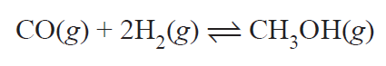

Once chemical equilibrium has been established, the concentrations of all species present in the reaction are recorded and graphed below.

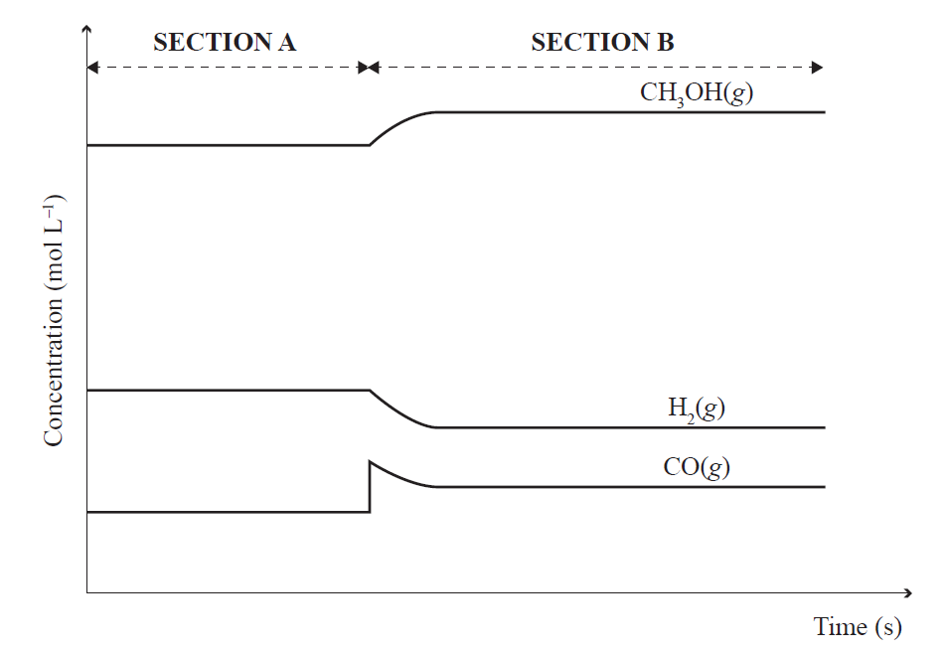

(i) Explain how the graph shows the system is at equilibrium throughout **Section A**.

Refer to the rates of the forward and reverse reactions in your answer

(ii) At the beginning of **Section B**, in the graph on the previous page, some carbon monoxide, CO(*g*), is

added to the reaction vessel.

Explain, using equilibrium principles, how the system responds to restore equilibrium.

Refer to the graph in your answer.

(iii) Using equilibrium principles, explain why carrying out the reaction at high pressure is advantageous in the manufacture of methanol, CH3OH(*g*).

2021

The following equation shows a system in equilibrium.



Explain, using equilibrium principles, the effect on the position of the equilibrium when:

(i) a small amount of concentrated ethanoic acid, CH3COOH(), is added.

(ii) dilute sodium hydroxide solution, NaOH(*aq*), is added.

(iii) When the temperature of the equilibrium system is increased, the *K*c value also increases.

Justify, using equilibrium principles, whether the forward reaction is exothermic or endothermic.

2020

The following equilibrium was established in the laboratory by mixing iron(III) nitrate solution, Fe(NO3)3(aq), with potassium thiocyanate solution, KSCN(aq).

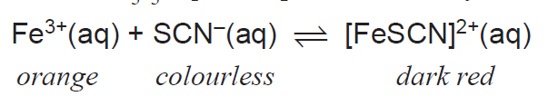

The forward reaction produces heat.

Explain, using equilibrium principles, the effect on the colour of the solution if:

(i) More potassium thiocyanate solution, KSCN(aq), is added to the reaction mixture.

(ii) Solid sodium fluoride is added to the mixture. The added F– ions react with the Fe3+ ions.

(iii) A test tube containing the reaction mixture is placed in a beaker of recently boiled water.

2019

The Haber process combines nitrogen, N2(*g*), from the air with hydrogen, H2(*g*), to form ammonia, NH3(*g*), which is then used in the manufacture of fertiliser.

The equation for this process is N2(*g*) + 3H2(*g*) ⇌ 2NH3(*g*)

(i) Using equilibrium principles, explain why carrying out the Haber process at high pressure is an

advantage to the manufacturer.

(ii) In another part of the process, the ammonia, NH3(*g*), is removed as it is produced.

Justify this using equilibrium principles to explain why this would be an advantage to a manufacturer.

2018

(i) Explain, using equilibrium principles, why it is important for an industrial plant to continue to remove

the sulfur trioxide gas, SO3(*g*), as it is produced.

2SO2 *(g)* + O2 *(g)* ⇌ 2SO3 *(g)*

(ii) Predict, using equilibrium principles, the effect on the concentration of sulfur trioxide gas, SO3(*g*), of

carrying out the reaction in a **larger** reaction vessel.

(iii) When the reaction is carried out at 450ºC, the *K*c value is higher than the value at 600°C.

Justify whether the oxidation of sulfur dioxide gas, SO2(*g*), to sulfur trioxide gas, SO3(*g*), is exothermic or endothermic.

2017

1. Two different cobalt(II) complex ions, [Co(H2O)6]2+ and [CoCl4]2–, exist together in a solution in

equilibrium with chloride ions, Cl–(*aq*).

The forward reaction is endothermic; Δ*H* is positive. The equation for this equilibrium is shown below.



Explain using equilibrium principles, the effect on the colour of the solution if:

(i) more water is added to the reaction mixture

(ii) a test tube containing the reaction mixture is placed in a beaker of ice-cold water.

2. Brown nitrogen dioxide gas, NO2(*g*), exists in equilibrium with the colourless gas, dinitrogen tetroxide, N2O4(*g*).



Explain using equilibrium principles, the effect of decreasing the volume of the container (therefore increasing the pressure) on the observations of this equilibrium mixture.

**2016**

When acid is added to a yellow solution of chromate ions, CrO42–(*aq*), the following equilibrium is established.



Analyse this equilibrium using equilibrium principles to explain the effect on the colour of the solution

when:

(i) more dilute acid is added:

(ii) dilute base is added:

**2015**

The reaction between ethanoic acid and ethanol is reversible. Ethyl ethanoate and water are the products formed. In a closed system, a dynamic equilibrium is set up.



(i) Explain, using equilibrium principles, the effect of adding more ethanol to the reaction mixture.

(ii) The reaction is quite slow, so a small amount of concentrated sulfuric acid is added as a catalyst.

Explain, using equilibrium principles, the effect of adding this catalyst to the equilibrium mixture.

**2014**

1. The reaction shown in the equation below is at equilibrium.



Describe the effect of each of the following changes on the equilibrium concentration of methanol (increase, decrease, stay the same). Justify your answers using equilibrium principles.

(i) A copper oxide, CuO, catalyst is added.  
Amount of CH3OH(g) would: **increase** OR **decrease** OR **stay the same**

(ii) H2 (g) is removed.Amount of CH3OH(*g*) would: **increase** OR **decrease** OR **stay the same**

2. In a reaction, the brown gas nitrogen dioxide, NO2(*g*), exists in equilibrium with the colourless gas

dinitrogen tetroxide, N2O4(*g*). The equation for this reaction is represented by:

2NO2(*g*) ⇄    N2O4(*g*)

brown gas colourless gas

The table below shows the observations when changes were made to the system.

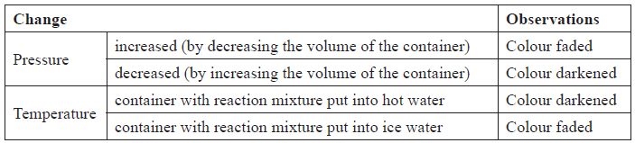

Analyse these experimental observations.

In your answer you should:

• link all of the observations to equilibrium principles

• justify whether the formation of dinitrogen tetroxide from nitrogen dioxide is endothermic or exothermic.

2013

The two reactions shown in the following table are both at equilibrium.



Compare and contrast the effect of increasing the pressure on both reactions, with reference to the equilibrium positions.

© <https://www.chemical-minds.com>

NCEA questions and answers reproduced with permission from NZQA