**Ionisation energy**

**2020**

Write the equation to show the reaction that has an enthalpy change equal to the first ionisation energy for the element arsenic, As.

Justify the difference in first ionisation energies for nitrogen, potassium, and arsenic.

**2018**

Explain the factors influencing the trends in first ionisation energy and atomic radius across the second

period of the periodic table.

In your answer, you should:

• describe the trends in both first ionisation energy and atomic radius across the second period

• explain the factors influencing the trends in first ionistion energy and atomic radius across the second

period

• relate the trend in first ionisation energy to the trend in atomic radius.

**2017**

The following graph shows the first ionisation energies of the Group 2 elements from Be to Ba.



(i) Write an equation to show the first ionisation energy for the element calcium.

(ii) Explain the trend shown of first ionisation energies of the Group 2 elements.

**2016**

Explain the factors influencing the trends in electronegativity and first ionisation energy down a group of the

periodic table.

In your answer you should:

• define both electronegativity and first ionisation energy

• explain the trend in both electronegativity and first ionisation energy down a group

• compare the trend in electronegativity and first ionisation energy down a group.

**2015**

(i) Define First ionisation energy

(ii) The following table shows the first ionisation energy values for elements in the third period of the periodic table.

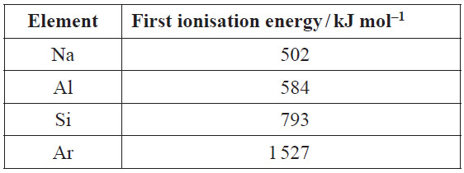

Justify the periodic trend of first ionisation energies shown by the data in the table above, and relate this to the expected trend in atomic radii across the third period.

**2014**

The following table shows the electron configurations of four atoms, He, B, N, and Ne.

#### Arrange these atoms in order of increasing first ionisation energy

#### 

**2013**

Discuss the data for the following pairs of particles.



**2013 Sample Exam**

A chlorine atom has a greater first ionisation energy than a sodium atom.

#### 2011

(i) Write a balanced ion-electron equation to show the first ionisation of lithium.

(ii) With reference to the graph below, discuss the general trends in ionisation energies from lithium to sodium, and account for any anomalies.



**2009**

Account for the differences in the property given below



**2008**

A bromine atom, Br, is smaller than a scandium atom, Sc, but its ionisation energy is larger.

© <https://www.chemical-minds.com>

NCEA questions and answers reproduced with permission from NZQA