Constitutional isomers and stereoisomers

**2019**

1. 2-chlorobutane can exist as enantiomers (optical isomers).



(i) Draw the enantiomers of 2-chlorobutane.

(ii) Explain how the two enantiomers of 2-chlorobutane could be distinguished.

2. *(edited)*

C5H10O can exist as a number of different constitutional (structural) isomers.

Draw the following isomers of C5H10O

(i) an aldehyde

(ii) a ketone

(iii) a five carbon ring cyclic molecule that is a tertiary alcohol

(iv) Straight-chain secondary alcohol that decolourises bromine water, and can exist as both *cis-trans* (geometric) isomers and enantiomers (optical isomers).

**2018**

The structural formula of 2,3-dihydroxypropanal, more commonly known as glyceraldehyde, is shown below.



Glyceraldehyde can exist as enantiomers (optical isomers).

(i) Draw the enantiomers of glyceraldehyde in the box below.

(ii) Explain why glyceraldehyde can exist as enantiomers.

(iii) How could the two enantiomers of glyceraldehyde be distinguished? Explain your answer.

**2017**

1. Some organic compounds can exist as enantiomers (optical isomers).

An example is a secondary alcohol with the molecular formula C4H9OH.

(i) Draw the enantiomers of C4H9OH

(ii) Explain what is meant by the term enantiomers (optical isomers).

In your answer, you should:

• identify the structural requirement for a molecule, such as C4H9OH, to exist as enantiomers

• explain how enantiomers can be distinguished from each other.

**2.** Compound **P** and compound **Q** are straight-chain constitutional (structural) isomers with the molecular formula C5H12O. Compound **P** can form optical isomers, whereas compound **Q** cannot. When reacted with concentrated sulfuric acid, compound **P** forms two products, compound **Q** forms only one product, compound **S**. Draw the structure of both P and Q

**2016**

Glycine, alanine, and serine are three amino acids shown below.



(i) Draw the 3-D structures of the enantiomers (optical isomers) of **serine.**

(ii) Circle the amino acid below which does NOT display optical isomerism:

**glycine alanine serine**

Explain your answer.

**2015**

Alanine is an amino acid. Its structure is shown below.

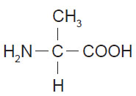

(a) (i) Describe the structural feature necessary for a compound to exist as enantiomers (optical isomers).

(ii) Identify one physical property that is the same for both enantiomers of alanine, and one that is different, clearly describing how this property could be used to distinguish between the enantiomers.

(b) Draw 3-D structures of the enantiomers of alanine.

**2014**

When butan-2-ol undergoes a reaction with concentrated H2SO4, three possible organic products form, which are isomers of each other.

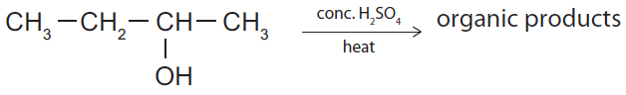

i) Draw the three isomers formed during this reaction.

ii) Which of the three isomers from part (i) will be formed in the smallest amount? Explain your answer.

© <https://www.chemical-minds.com>

NCEA questions and answers reproduced with permission from NZQA