Relative concentrations of dissolved species

**2019**

Two solutions of equal concentration were prepared: one of ethanoic acid, CH3COOH, and one of

ammonium chloride, NH4Cl.

p*K*a(CH3COOH) = 4.76 p*K*a(NH4+) = 9.24

(i) Explain which solution would have the lower pH.

Your answer should refer to the concentration of relevant ion(s) in each solution.

*No calculations are necessary.*

**2017**

Hydrogen fluoride, HF, and hydrogen bromide, HBr, both form acidic solutions when added to water.

(i) Write an equation for the reaction of each acid with water.

Hydrogen fluoride, HF, with water:

Hydrogen bromide, HBr, with water:

(ii) Compare and contrast the electrical conductivity of 0.150 mol L–1 solutions of hydrofluoric acid, HF,

and hydrobromic acid, HBr. In your answer, you should:

• include the requirements for a solution to conduct electricity

• identify the species present AND their relative concentrations.

*No calculations are necessary.*

**2016**

Ethyl ammonium chloride, CH3CH2NH3Cl, is a weak acid that will also react with water.

List all the species present in a solution of CH3CH2NH3Cl, in order of decreasing concentration.

*Do not include water.*

Justify the order you have given. Include equations, where necessary.

**2015**

(a) Methylammonium chloride, CH3NH3Cl, dissolves in water to form a weakly acidic solution.

*K*a(CH3NH3+) = 2.29 × 10–11

(i) Write an equation to show CH3NH3Cl dissolving in water.

(ii) Write an equation to show the reaction occurring in an aqueous solution of CH3NH3Cl.

(iii) List all the species present in an aqueous solution of CH3NH3Cl, in order of decreasing concentration.

*Do not include water.*

(b)The table shows the pH and electrical conductivity of three solutions. The concentrations of the solutions are the same.



Compare and contrast the pH and electrical conductivity of these three solutions.

Include appropriate equations in your answer.

**2014**

When chlorine gas is added to water, the equation for the reaction is:

Cl2(*g*) + H2O(l) ⇌  HCl(*aq*) + HOCl(*aq*)

(i) Write an equation for the reaction of the weak acid, hypochlorous acid, HOCl, with water.

(ii) List all the species present when HOCl reacts with water, in order of decreasing concentration.

Justify your order.

**2013**

(a) 1 mol of each of the following substances was placed in separate flasks, and water was added to these

flasks to give a total volume of 1 L for each solution, rank these solutions in order of increasingpH.

Justify your choice and include equations where appropriate. CH3NH3Cl, CH3NH2, HCl

(b) The conductivity of the 1 mol L–1 solutions formed in (a) can be measured, rank these solutions in order

of decreasing conductivity. Compare and contrast the conductivity of each of the 1 mol L–1 solutions, with

reference to species in solution.

**2012**

(a) Write equations for the reactions occurring when each of the following is added to water.

(i) HCl

(ii) CH3NH2

(iii) NH4Cl

(b) For each of the following 0.100 mol L–1 solutions, list all species in order of decreasing concentration.

*Do not include water.*

(i) HCl

(ii) CH3NH2

(iii) NH4Cl

(c) Compare and contrast the pH and electrical conductivity of 0.100 mol L–1 solutions of HCl, CH3NH2

and NH4Cl. *No calculations are necessary.*

**2011**

a) Classify the following 0.100 mol L–1 solutions by writing the correct description from the terms below.

**strong acid weak acid neutral weak base strong base**

**NH3 NaCl NH4Cl HF**

b) Discuss the relative concentrations of the species present in each of the 0.100 mol L–1 solutions of NH3

and HF. *You do not need to include water.*

Include in your answer:

• any relevant equations

• a ranking of the species present in each solution in order of **decreasing** concentration

• justification for the ranking of the species.

*No calculations are necessary.*

**2010**

(a) An aqueous solution of ammonium chloride (NH4Cl) has a pH of 4.66.

(i) Write the equation for solid ammonium chloride dissolving in water.

(ii) Write the equation for the ammonium ion reacting with water.

(b) The bar chart below shows the relative concentrations of the species (excluding water) in a solution of 0.1 mol L–1 NH4Cl. (The bar chart is not drawn to scale.)

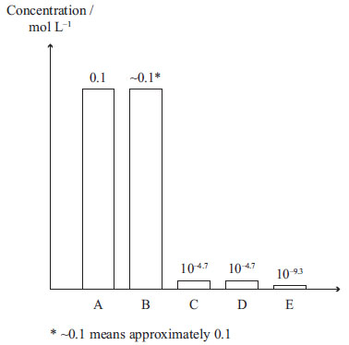

Identify the species **A** to **E**. Justify your answer

© <https://www.chemical-minds.com>

NCEA questions and answers reproduced with permission from NZQA