**NCEA past examination questions on practical procedures in organic chemistry**

**2017**

Adding an acidified potassium dichromate solution to propan-1-ol can produce either propanal or propanoic

acid. Explain the laboratory procedure used to convert propan-1-ol to **propanal**.

In your answer, you should:

• outline the procedure for the conversion, and describe any colour changes linked to the species involved

• state the type of reaction occurring

• explain how the procedure ensures only **propanal** is collected.

**2015**

Explain why the equipment below is used for hydrolysis of a triglyceride.

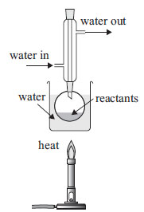

**2014**

Instructions for the preparation of 2-chloro-2-methylpropane are given below.

Read the instructions carefully and answer the questions that follow.

1. Shake 10 mL of 2-methylpropan-2-ol with 30 mL of concentrated hydrochloric acid in a separating funnel for 10 minutes.

2. Run off the bottom acid layer and discard it. Add saturated sodium hydrogen carbonate to the organic product. Shake, releasing the tap every few seconds to relieve the pressure.

3. Run off the bottom aqueous layer and discard it. Transfer into a conical flask and add some anhydrous sodium sulfate, and stir thoroughly.4. Transfer the organic product into a round-bottom flask, and collect the

fraction boiling within 2oC of the boiling point of 2-chloro-2-methylpropane.

(i) Explain why the solution of sodium hydrogen carbonate is added in instruction 2 and name the gas

produced in this step.

(ii) Explain why anhydrous sodium sulfate is added in instruction 3.

(iii) Name the process used in instruction 4 to purify the organic product. Write the number of the

equipment that a student would use to perform this process from the diagrams below.

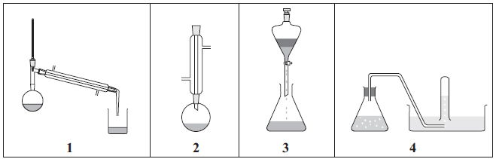

(iv) Discuss the process carried out in instruction 4. Include in your answer:

• the purpose of this process

• an explanation of how it works.

**2013**

Discuss the laboratory procedures used to convert butan-1-ol into butanal, and butan-1-ol into butanoic

acid. In each discussion, you should:

• outline the process for each conversion

• state and justify the type of reaction occurring

• identify the reagents used, and explain any observations made.

**2011**

i) Refluxing is often required in reactions involving organic substances. Circle the letter of the

apparatus below that would be used in this procedure.



ii) Discuss why refluxing is sometimes used.

**2010**

A description of a laboratory procedure that could be used for the preparation of 2-chloro-2-methylbutane from 2-methylbutan-2-ol, is given in the table below.





Discuss this procedure by:

(i) explaining why the following reagents are used

concentrated HCl

sodium hydrogencarbonate (NaHCO3)

anhydrous sodium sulfate (Na2SO4)

(ii) justifying the use of the apparatus pictured in terms of the properties of the compounds involved

separating funnel

distillation apparatus

**2008**

**1.** Propan-1-ol can be oxidised to produce two different products.

Discuss how to carry out the oxidation of propan-1-ol in the laboratory to obtain two different organic products. The method may use two different samples of propan-1-ol to form each product.

**2.** Esters are often responsible for the flavouring of fruit. The compound below is an ester with a raspberry flavour.



Esters can be prepared by *refluxing* the reactants with a small amount of **concentrated sulfuric acid**. After refluxing, the reaction mixture is treated with **potassium carbonate** and *distilled*.

Discuss the preparation of the ester shown above. Your answer should include:

• an appropriate chemical equation for the formation of the ester

• the reason for using the chemicals stated in bold above

• a discussion of why reflux and distillation are used in this preparation.

**2006**

a) A student thoroughly mixed 20 mL of concentrated hydrochloric acid with 10 mL of

2-methylpropan2-ol.

i) Describe any observation that could be made as a result of the reaction occurring.

ii) Draw and name the structure of the organic product.

b) In the preparation, the *impure organic product was initially separated* from the reaction mixture.

Aqueous **sodium carbonate** was added to the organic product and when reaction ceased, the *organic*

*product was again separated*. **Anhydrous magnesium sulfate** was added to the organic product, which was

then transferred to a flask and *purified by distillation*.

i) Explain why each of the substances identified in bold above was added.

ii) The diagrams below show four different experimental arrangements of equipment.

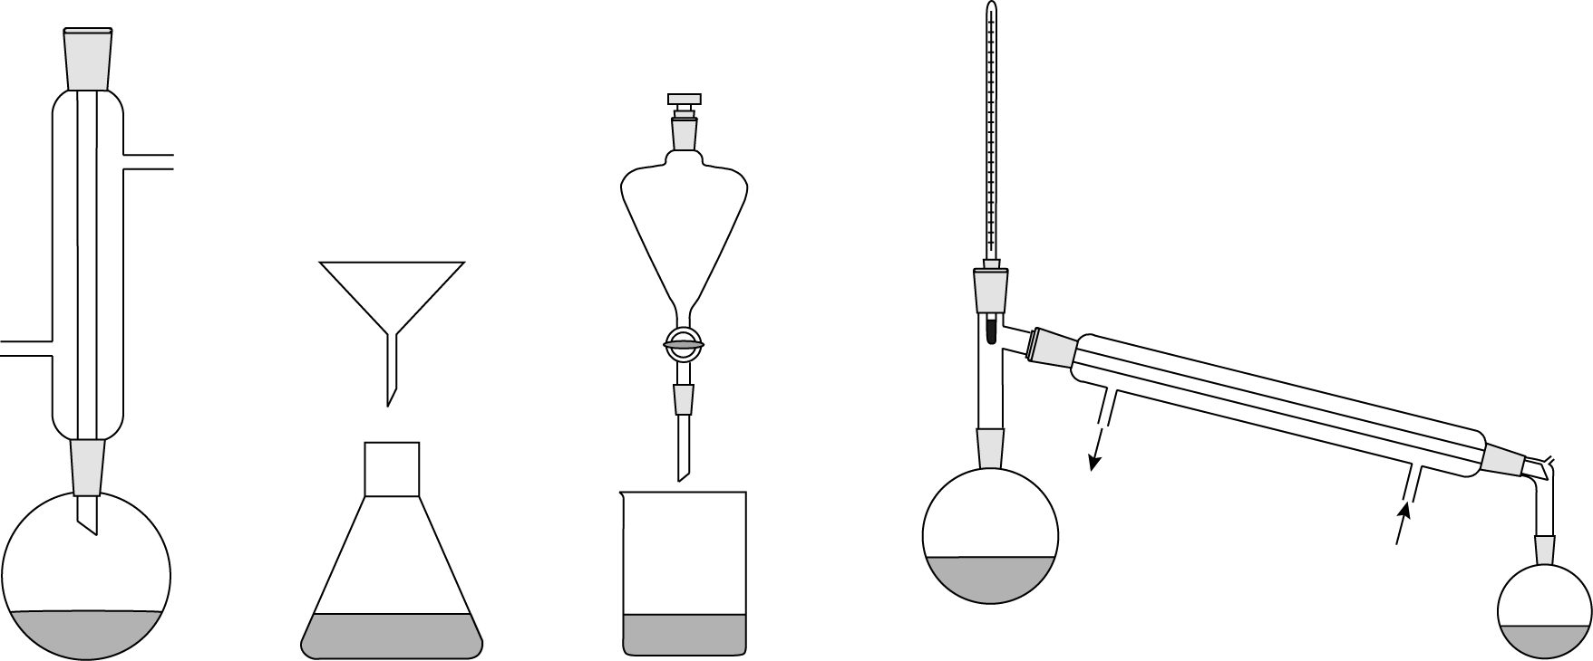

A B C D

Using one or more of the sets of apparatus shown, discuss how each of the separation processes,

identified in *italics* above, is carried out.

© 2018 <https://www.chemical-minds.com>

NCEA questions and answers reproduced with permission from NZQA