**Rate of reactions**

**2022**

1. The formation of methanol, CH3OH(*g*), from carbon monoxide, CO(*g*), and hydrogen, H2(*g*), is a slow

reaction. To increase the rate of reaction, a small amount of zinc oxide, ZnO(*s*), can be added. This zinc

oxide can be recovered after the reaction is complete.

(i) State the role of the zinc oxide, ZnO(*s*), in the reaction.

(ii) An energy diagram for the reaction without the use of zinc oxide, ZnO(*s*), is shown below.

Add a line to show how the diagram would differ when zinc oxide is added.

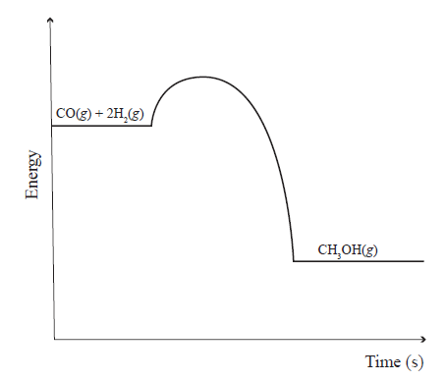

(iii) Explain how zinc oxide, ZnO(*s*), increases the rate of reaction.

Refer to collision theory and activation energy in your answer.

2. A solution of sodium carbonate, Na2CO3(*aq*) was then used in a reaction with hydrochloric acid,

HCl(*aq*).

The equation for the reaction is shown below.

Na2CO3(*aq*) + 2HCl(*aq*) → 2NaCl(*aq*) + H2O(l) + CO2(*g*)

The reaction was carried out at both 25 °C and 50 °C, and the volume of CO2 gas produced was recorded on the graph below.

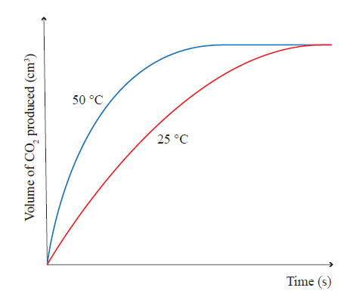

In both reactions, the same concentration and volume of each solution is used.

Explain the effect of increased temperature upon the rate of reaction.

In your answer you should:

• refer to collision theory

• consider both the rate of CO2 production, and the total volume of CO2 formed, for each reaction

• refer to the lines on the graph above.

**2021**

(a) Calcium carbonate chips, CaCO3(*s*), react with a solution of hydrochloric acid, HCl(*aq*). The reaction is

represented by the equation:

CaCO3(*s*) + 2HCl(*aq*) → CaCl2(*aq*) + CO2(*g*) + H2O(l)

The reaction is monitored by measuring the decrease in mass of the reaction mixture over time. This is shown below.

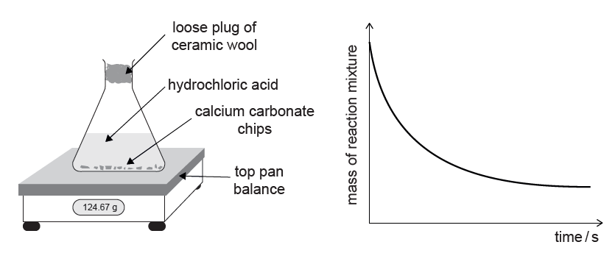

(i) Why does the reaction mixture decrease in mass as the reaction proceeds?

(ii) Explain the changes in the rate of reaction between calcium carbonate chips, CaCO3(*s*), and

hydrochloric acid, HCl(*aq*), as the reaction proceeds.

Refer to the shape of the graph in your answer.

(b) Two further reactions were set up between 5.00 g of calcium carbonate, CaCO3(*s*), and 100 mL of hydrochloric acid, HCl(*aq*), as follows.

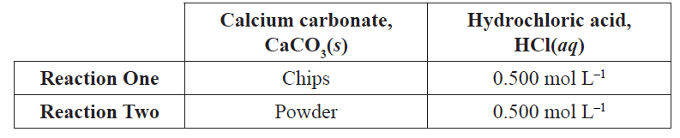

Compare and contrast these two reactions.

Refer to collision theory and rates of reaction in your answer.

You should consider the total mass loss of each reaction.

(c) The decomposition reaction of hydrogen peroxide solution, H2O2(*aq*), is a slow reaction. This reaction is

represented by the equation:

2H2O2(*aq*) → 2H2O(l) + O2(*g*)

The ‘elephant’s toothpaste’ experiment shows how the rate of the decomposition reaction can be changed by adding a small amount of potassium iodide, KI(*s*). When potassium iodide is added, large amounts of foam are produced as a result of the rapid production of oxygen gas.

(i) State the role of potassium iodide, KI(*s*), in this reaction.

(ii) Elaborate on how potassium iodide, KI(*s*), changes the rate of the reaction.

In your answer you should refer to activation energy and collision theory.

You may also include diagrams in your answer.

**2020**

|  |  |
| --- | --- |
| When oxalic acid solution, H2C2O4(aq), reacts with purple acidified potassium permanganate solution, H+ / MnO4–(aq), the purple colour fades and the reaction is complete when the mixture turns colourless.  The picture shows the colour changes after 45 seconds for three different temperatures.  (a) Explain how the rate of reaction for this experiment is affected by the  temperature at which the reaction occurs.  In your answer refer to the information in the picture, collision theory, and activation energy. |  |

(b) 2.0 g of powdered calcium carbonate, CaCO3(*s*), is added to each of the three solutions, A, B, and C,

above. The volume of acid in each solution is the same.

Identify which solution would have the highest rate of reaction with CaCO3(*s*).

Explain your answer, with reference to collision theory.

**2019**

The same volume and concentration of hydrochloric acid, HCl(*aq*), was added to each of three test tubes. Metal samples were added, according to the table and diagram below.

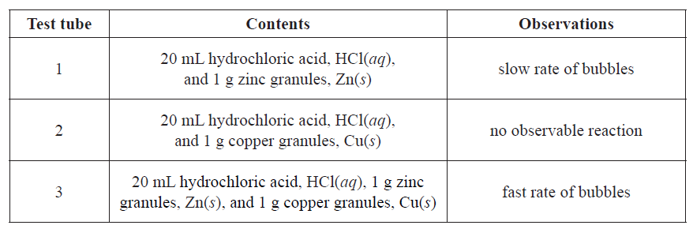

(i) Identify the role of the copper granules, Cu(*s*), in test tube 3.

(ii) Explain the role of copper, Cu(*s*), in this reaction. You should refer to activation energy and collision

theory in your answer.

**(b)** In a second investigation, two 20 mL samples of 0.2 mol L–1 sulfuric acid, H2SO4(*aq*), were placed in separate conical flasks. One of the flasks was placed in a water bath at 40°C and the other was placed in a water bath at 20°C. To each conical flask, 5.0 g of zinc granules, Zn(*s*), were added. The gas produced was collected and measured over time and the following graph was produced.

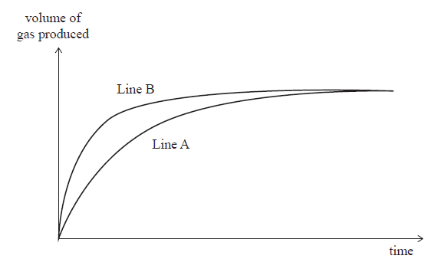

**(i)** Identify which line on the graph represents the reaction at 40°C, and explain why the two lines still finish in the same position.

(ii) Elaborate on the effect of increasing temperature on the rate of reaction.

Refer to collision theory and activation energy in your answer.

**2018**

In the iodine clock reaction, a solution of hydrogen peroxide is mixed with a solution containing potassium

iodide, starch, and sodium thiosulfate.

After some time, the colourless mixture suddenly turns dark blue.

The table shows the time taken for the reaction performed at different temperatures. The concentration of all reactants was kept constant.

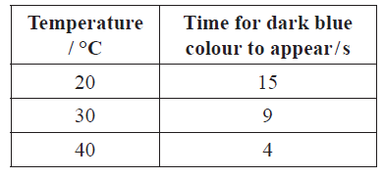

Explain the effect of changing the temperature on the rate of reaction.

Refer to collision theory and activation energy in your answer.

**(b)** Consider the following observations in another experiment using hydrogen peroxide:

• When hydrogen peroxide is mixed with solution **X**, which contains universal indicator, the colour changes

from blue to green to yellow to orange-red **over a time of one hour**.

• If a crystal of **ammonium molybdate** is added to solution **X** before the hydrogen peroxide is added, the

same colour changes will be seen in **three to four minutes**.

(i) Identify and explain the role of ammonium molybdate.

Use a diagram and refer to activation energy in your answer.

**2017**

**1.** The addition of a small amount of iron to a mixture of nitrogen and hydrogen gases helps to speed up the production of ammonia gas.

N2(*g*) + 3H2(*g*) ⇌ 2NH3(*g*)

(a) Identify and explain the role of iron in this reaction. In your answer, you should refer to activation

energy and collision theory. You may include a diagram or diagrams in your answer.

**2. (a)** Consider the reaction between calcium carbonate powder, CaCO3(*s*), and a solution of hydrochloric

acid, HCl(*aq*). As the reaction proceeds, the mass of the reaction mixture decreases as carbon dioxide gas,

CO2(*g*), escapes. This is represented on the graph below.

Line A represents the reaction occurring at 20°C and line B represents the reaction occurring at 40°C.



Compare and contrast the reaction between calcium carbonate powder, CaCO3(*s*), and a solution of

hydrochloric acid, HCl(*aq*) at two temperatures: 20°C and 40°C, assuming all other conditions are kept the

same. Your answer should refer to collision theory and rates of reaction.

**2016**

(a) Cleaned magnesium ribbon, Mg(*s*), reacts with a solution of hydrochloric acid, HCl(*aq*). The reaction is

represented by the equation:

Mg(*s*) + 2HCl(*aq*) → MgCl2(*aq*) + H2(*g*)

The reaction is monitored by measuring the volume of hydrogen gas produced over a given period of time. This is shown in the graph below.



Explain the changes in the rate of reaction between magnesium, Mg(*s*), and hydrochloric acid, HCl(*aq*), in

terms of collision theory. Refer to parts A, B, and C of the graph in your answer.

(b) Compare and contrast the reactions of 0.5 g of magnesium ribbon, Mg(*s*), with 50.0 mL of 0.100 mol L–1 hydrochloric acid, HCl(*aq*), and 0.5 g of magnesium powder, Mg(*s*), with 50.0 mL of 0.100 mol L–1 hydrochloric acid, HCl(*aq*).

Refer to collision theory and rates of reaction in your answer.

(c) The decomposition reaction of hydrogen peroxide solution, H2O2(*aq*), is a slow reaction. This reaction is represented by the equation

2H2O2(*aq*) → 2H2O(l) + O2(*g*)

The rate of the decomposition reaction can be changed by adding a small amount of manganese dioxide, MnO2(*s*). The graph below shows the volume of oxygen gas formed in the reaction with and without manganese dioxide, MnO2(*s*).



(i) State the role of manganese dioxide, MnO2(*s*), in this reaction.

(ii) Elaborate on how manganese dioxide, MnO2(*s*), changes the rate of the decomposition reaction of the

hydrogen peroxide, H2O2(*aq)*.

In your answer you should refer to the activation energy and collision theory.

You may also include diagrams in your answer.

**2015**

The ‘elephant toothpaste’ demonstration shows the decomposition of hydrogen peroxide, H2O2, into water and oxygen gas.

2H2O2(*aq*) → 2H2O(l) + O2(*g*)

This reaction can be observed by adding detergent to the hydrogen peroxide solution. As oxygen gas is produced, the detergent foams up, as seen in the photograph on the right. The time taken for the foam to reach the top of the measuring cylinder can be used to measure the rate of the reaction.

Three experiments were carried out to investigate factors that change the rate of the reaction.



(a) The decomposition reaction of hydrogen peroxide, H2O2, is very slow. By adding a small amount of powdered manganese dioxide, MnO2, the rate of the reaction can be increased.

(i) Explain why only a small amount of manganese dioxide is needed to increase the rate of the reaction.

(ii) The diagram below shows the energy diagram for the decomposition reaction **without** manganese dioxide.

Label this diagram and use it to help you explain how the addition of manganese dioxide speeds up the rate of the reaction.



(b) Compare Experiment 2 with Experiment 1.

In your answer, you should:

• identify the factor being changed, and the effect this will have on the rate of reaction

• explain the effect on the rate of reaction by referring to the collision of particles and activation energy, where appropriate.

(c) Compare Experiment 3 with Experiment 1.

In your answer, you should:

• identify the factor being changed, and the effect this will have on the rate of reaction

• explain the effect on the rate of reaction by referring to the collision of particles and activation energy, where appropriate.

**2014**

(a) The equation for the reaction between zinc granules (lumps), Zn(*s*), and sulfuric acid, H2SO4(*aq*), is

represented by:

Zn(*s*) + H2SO4(*aq*) → ZnSO4(*aq*) + H2(*g*)

The graph below shows how the volume of hydrogen gas produced changes with time, when zinc is reacted with excess sulfuric acid at 20°C.

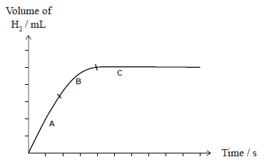

Explain the changes in the reaction rate during the periods **A**, **B** and **C**.

In your answer you should refer to collision theory.

(b) The rate of the reaction between zinc and sulfuric acid can be changed by the addition of small pieces of

copper, Cu(*s*), as a catalyst.

Explain the role of the copper catalyst in the reaction between zinc and sulfuric acid. In your answer you

should refer to collision theory.

**2013**

**(a)** Hydrochloric acid was reacted with calcium carbonate in the form of marble chips (lumps) and powder (crushed marble chips) in an experiment to investigate factors affecting the rate of a chemical reaction.

(i) Identify the factor being investigated.

(ii) Explain why the hydrochloric acid would react faster with the powder.

b) A *clock reaction* involves mixing solution X and solution Y with starch present. When the reaction is

complete the solution turns blue-black in colour. A student carried out this reaction between solution X and

solution Y in a conical flask. Over time, the cross on the piece of paper under the flask disappeared when

viewed from above.



The following experiments were carried out, and the times taken for the cross to disappear recorded.



Elaborate on why the reactions in **Experiment 2** and **Experiment 3** occur faster than the reaction in

**Experiment 1**. In your answer, include the following words or terms.

**collisions activation energy temperature effective catalyst**

© <https://www.chemical-minds.com>

NCEA questions and answers reproduced with permission from NZQA