Shapes of molecules

QUESTION: For each of the molecules shown in the table
i) name the shape of each molecule
ii) state the bond angles

BCl₃ | COBr₂
F₂CO | AsF₃ | 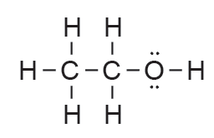  shape around C and O atoms?
CCl₃F | N₂O | NOCl
HOCl | NH₃ | N₂H₄
CH₄ | AsH₃ | NF₃
BF₃ | PF₃ | CCl₄
PH₃ | CO₂ | H₂CO (or CH₂O)
H₂O | CH₂Br₂ or CH₂Cl₂ | CS₂
O₂ | CH₃Br or CH₃Cl | SO₂
XO₂  (where X has 4 valence electrons) | YO₂  (where Y has 6 valence electrons) | NCl₃
PBr₃ or PCl₃ | H₂S | COCl₂
OCl₂ aka Cl₂O | SiCl₄ | HCN
SF₂ | F₂O or OF₂ | N₂

© https://www.chemical-minds.com
NCEA questions and answers reproduced with permission from NZQA

