**Explaining polarity of molecules**

**2023**

Carbon dioxide contains carbon and oxygen atoms. Oxygen is more electronegative than carbon. Compare and contrast the factors that influence the polarity of carbon dioxide and water.

**2022**

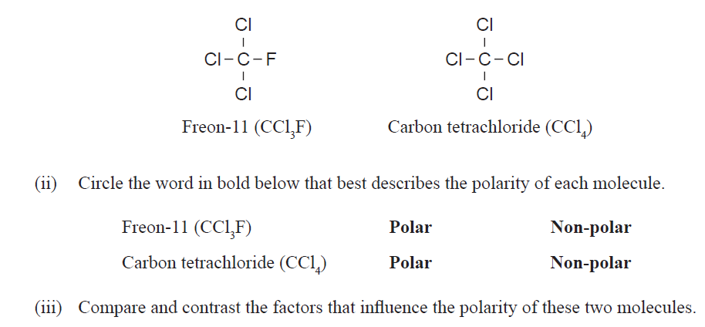

**2021**



**2020**

A molecular compound consists of two different elements, X and Z, and contains three atoms. Its formula is

ZX2. The elements have different electronegativities.

Depending on the identity of the elements, the molecule could be either polar or non-polar.

(i) State the likely shape if the molecule is: **polar non-polar**

**(ii)** Justify your answer by explaining the factors that affect polarity.

You do not need to identify elements X or Z, or specific molecules.

**2019**

The following table shows the Lewis structures (electron dot diagrams) for the molecules, CHCl3 and NH3.



(i) In the boxes above, identify the polarity of each molecule by writing either **polar** or **non-polar**.

(ii) Justify your choices.

**2018**

The Lewis structures for two molecules are shown below.



Hydrogen cyanide, HCN, is polar, and carbon dioxide, CO2, is nonpolar.

Both molecules are linear.

Explain why the polarities of the molecules are different, even though their shapes are the same.

**2017**

Three-dimensional diagrams for two molecules are shown below.



(i) In the boxes above, identify the polarity of each molecule, by writing either **polar** or **non-polar.**

(ii) Justify your choices.

**2016**

The Lewis structures for two molecules are shown.



Ammonia, NH3, is polar, and borane, BH3, is non-polar.

Justify this statement.

**2015**

BeCl2 and BF3 are unusual molecules because there are not enough electrons for the central atoms, Be and B, to have a full valence shell. Their Lewis structures are shown below.



Both molecules have the same polarity.

Circle the word that describes the polarity of these molecules.

**2014**

Molecules can be described as being polar or non-polar.

The following diagrams show the Lewis structures for two molecules, **SO**2 and **CO**2.



Circle the term that describes the **polarity** of each of the molecules.



For each molecule, justify your choice.

© <https://www.chemical-minds.com>

NCEA questions and answers reproduced with permission from NZQA­