Explaining shape and polarity of molecules

**2019**

The Lewis structure of ClF5 is given below.



Identify and explain the shape and polarity of ClF5.

**2018**

The Lewis diagram and shape for XeF4 are given below.



Elaborate on the shape and polarity of XeF4

**2017**

(a) (i) Draw the Lewis structure for the I3– ion

(ii) Explain why the I3– ion has a linear shape.

b) IF5 has a square pyramidal shape.

Indicate whether the molecule IF5 is polar or non-polar. Justify your choice.

**2016**

(i)Complete the following table:



(ii) The Lewis diagram for SeF6 is shown below.



Would you expect SeF6 to be soluble in water?

Explain your answer in terms of the shape and polarity of SeF6.

**2015**

(a) Complete the following table.



(b)The Lewis diagrams and shapes for XeO2F2 and GeH4 are shown below.

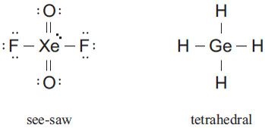

Compare and contrast the polarities and shapes of these two molecules.

**2014**

The halogens make up Group 17 of the periodic table. The polarity of the HBr molecule is shown below.

δ+ δ–

H — Br

Using this as an example, indicate the polarity of the following bonds by indicating any dipoles present.

1. F **—** Cl 2. At **—** Cl

**2013**

The Lewis diagrams for SF4 and XeF4 are shown below.



Compare and contrast the polarities and shapes of these two molecules.

© <http://www.chemical-minds.com>

NCEA questions and answers reproduced with permission from NZQA