**Polymerisation of alkenes**

**2022**

**Compound B** is able to form **Polymer H**, as shown below.

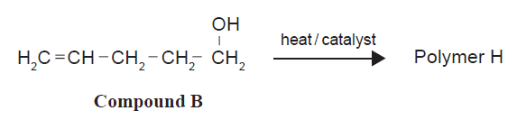

**(i)** Draw TWO repeating units of **Polymer H**.

**2021**

The compound below can undergo addition polymerisation reactions.



(i) Draw THREE repeat units of the polymer formed from **Compound F**.

**Compound A** cannot undergo addition polymerisation.



(ii) Explain the differences in both the structure and reactivity of **Compounds A** and **F** to account for this.

In your answer you should:

• explain the term addition polymerisation

• identify any differences in the structures of **Compounds A** and **F** and link this to the difference in reactivity discussed above.

**2020**

A section of the Teflon polymer chain is shown below. Teflon is best known for its use in coating non-stick frying pans and other cookware.

(i) Draw and name the structure of the monomer used to make this polymer.

(ii) The chemical reactivity of the monomer and polymer are different. Analyse this difference.

In your answer you should:

• link the structure of the monomer and polymer to its reactivity

• explain the importance of this difference for Teflon’s use as a polymer.

**2019**

**Draw and name compound A**

**2018**

Perspex® is a polymer used as an alternative to glass as it is transparent, lightweight, and shatter resistant. It can be made from the monomer shown below.



(i) Draw THREE repeating units of the polymer formed.

(ii) Justify whether or not the **monomer** used to produce Perspex® is a geometric (cis-trans) isomer by explaining the features required for this type of isomerism.

**2017**

Polyvinyl chloride (polychloroethene) is often used to make artificial leather. This can then be used to cover

chairs, cover car seats, and make clothing.

A section of a polyvinyl chloride molecule is shown below.



(i) Draw the monomer from which the polymer polyvinyl chloride would be made.

(ii) Explain the difference in the structures and chemical reactivity of the monomer and polymer, and why the difference is important for the uses of the polymer.

(iii) Making polyvinyl chloride (polychloroethene) from its monomer is called ‘addition polymerisation’.

Explain the term ‘addition polymerisation’ using polyvinyl chloride as an example.

Include an equation in your answer.

**2016**

Polystyrene is a polymer with the structure:



(i) Draw the monomer used to make the polymer polystyrene.

(ii) Explain why the formation of polystyrene from its monomer is classified as an addition polymerisation reaction.

**2015**

Cling Wrap is a polymer that can be made from the monomer 1,1-dichloroethene.

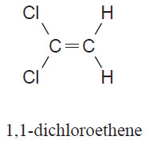

Draw THREE repeating units of the polymer formed.

**2014**

|  |  |
| --- | --- |
|  | http://www.chemistryrules.me.uk/candr/but1ene.gif |

**(i) Draw TWO repeating units of the polymer formed in reaction 5**

**(ii) Compare and contrast the polymer formed in reaction 5 to the polymer formed in reaction 3.**

**In your answer you should explain why the polymers formed in these two reactions are different.**

**2013**

**(i)** The molecule tetrafluoroethene is the monomer for the polymer commonly known as Teflon.

CF2=CF2

Draw TWO repeating units for the Teflon polymer.

(ii)The following diagram shows three repeating sections of another polymer.

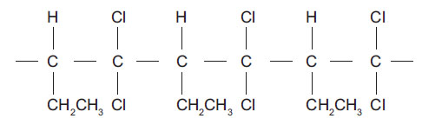

Draw the structural formula of the monomer molecule used to make this polymer.

**2012**

Draw two repeating units of the polymer formed from but-

<https://www.chemical-minds.com>

NCEA questions and answers reproduced with permission from NZQA