**ANSWERS: Rate of reactions**

2022

1.

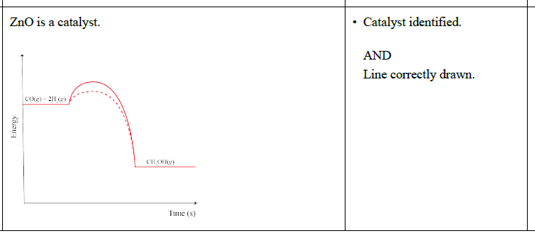

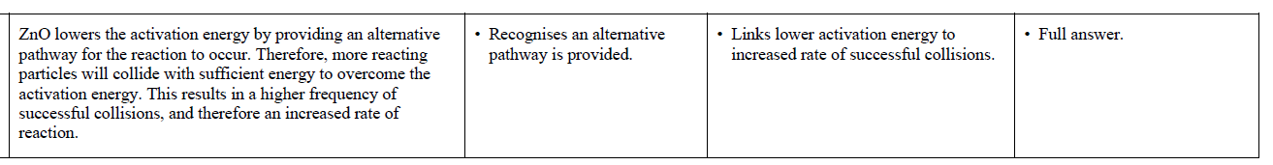

2.

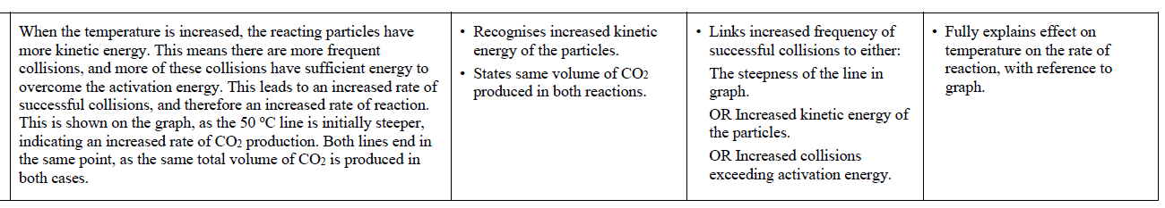

2021



2020

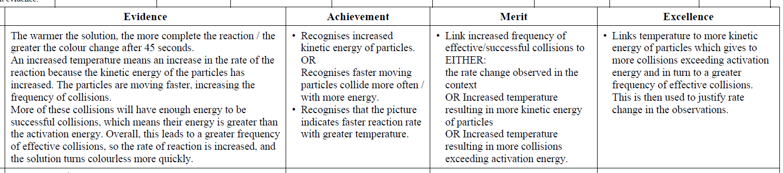

Uses the extent of ionisation to illustrate the ability of each acid to conduct electricity.

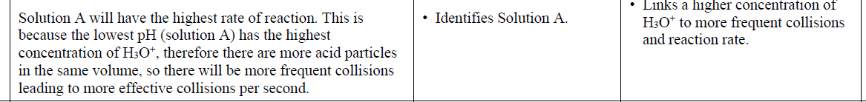

2019

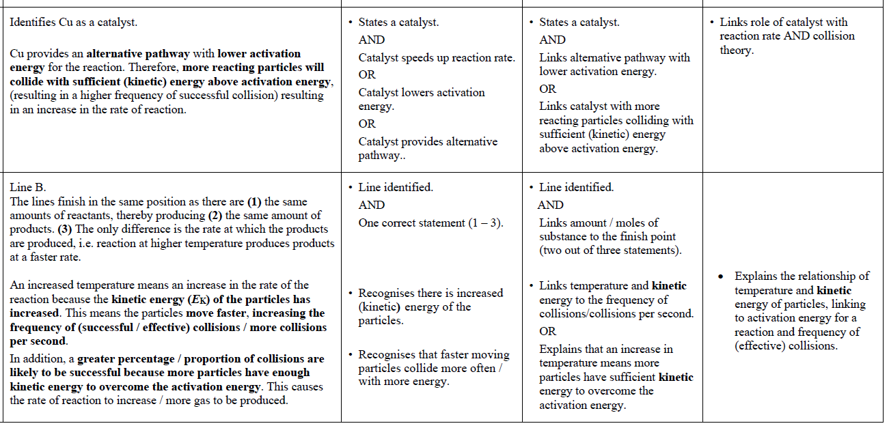

2018

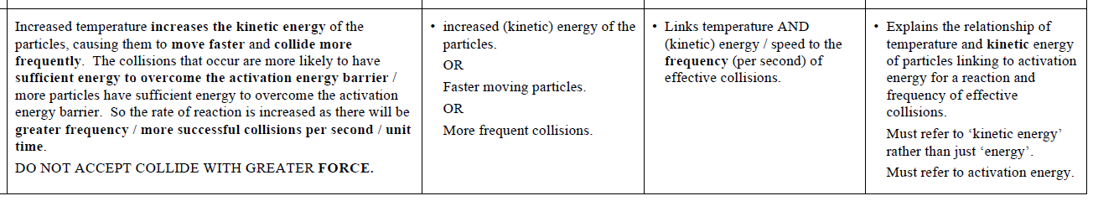

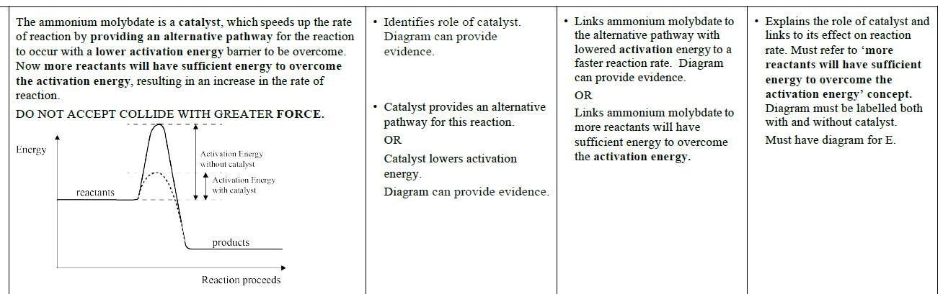

|  |  |  |  |  |
| --- | --- | --- | --- | --- |
| **2017** | **Evidence** | **Achievement** | **Merit** | **Excellence** |
| 1 | The iron is added to act as a catalyst. This speeds up the rate of reaction because a catalyst provides an alternative pathway for the reaction with a lower activation energy level. Therefore, **more particles / collisions have sufficient energy to overcome the activation energy**, and so there are more effective collisions /faster rate of reaction. | • Identifies iron as a catalyst  OR  Catalysts provide an alternative pathway for this reaction.  • The catalyst is not used up  OR  Lower activation energy is needed. | Alternative pathway with lower  activation energy.  OR  More collisions have sufficient  energy to overcome the activation energy, and so there are more effective collisions / faster rate of reaction. | Explains the role of the catalyst linked to the activation energy and  collision theory.  *Must have explanation in “bold”* |

|  |  |  |  |  |
| --- | --- | --- | --- | --- |
| 2 | The increased temperature means an increase in the rate of the reaction because the kinetic energy of the particles has increased. This means the particles move faster, increasing the frequency of collisions / more collisions per second, resulting in the CO2 gas being lost in a shorter period of time at 40°C than 20°C.  In addition, the collisions are more likely to be successful / effective because the average kinetic energy of the particles has increased, so a greater proportion of particles have enough / sufficient energy to overcome the activation energy.  This causes the rate of reaction to increase. Overall, the same mass is lost in both reactions. | Increased (kinetic) energy of the particles  OR  Increased number of collisions  OR  Particles move faster. | Links temperature and kinetic energy to the frequency / effectiveness of the collisions. | Links temperature and kinetic energy to frequency of collisions and activation energy, and the  increased rate of reaction.  (*For E8, indication of the same mass of CO2 released*  *OR*  *same mass of reaction*  *mixture at the end*). |

|  |  |  |  |  |
| --- | --- | --- | --- | --- |
| **2016** | **Evidence** | **Achievement** | **Merit** | **Excellence** |
| (a) | Initially the rate of the reaction is fast, as shown by the steepness of Part A in the graph. This is because the concentrations of the reactants, Mg and HCl, are at their highest, resulting in a high frequency of effective collisions, so the rate of reaction is highest there.  As time proceeds, the reactants are forming the products MgCl2 and H2 gas, so the concentration of the reactants decreases, resulting in fewer reactant particles available to react. This results in a decrease in the frequency of effective collisions between reacting particles and a decrease in the production of H2 gas, as shown in Part B of the graph where the gradient of the graph becomes less steep. Consequently, the rate of reaction decreases.  Once all of one reactant (or both) has been used up, the reaction will stop, so no H2 gas is produced, as shown on the graph in Part C as a horizontal line. | * Describes the rate of the reaction for one stage of the reaction (fast, decreases, stops).   • Describes the relative  concentrations of the reactants for one stage of the reaction (highest, decreasing, used up). | Explains the rate of reaction for TWO parts of the reaction in terms of reactant concentration and collision theory (must refer to frequency of collisions or collisions per second for at least one part). |  |
| (b) | In the reaction of hydrochloric acid with Mg ribbon and Mg powder, both form the same products, magnesium chloride and hydrogen gas.  Mg(*s*) + 2HCl(*aq*) → MgCl2(*aq*) + H2(*g*)  However, since Mg powder has a larger surface area than Mg ribbon, the powder will have more Mg particles immediately available to collide, there will be more effective collisions per second and more H2 gas will be produced initially, resulting in a faster rate of reaction.  Mg ribbon will take longer to react because fewer particles are immediately available to collide, so will have a slower rate of reaction.  Both reactions will eventually produce the same volume of hydrogen gas as the same amounts of each reactant are used. | * Describes the different surface areas in each reaction.   OR   * Describes the rate of reaction / production of the H2(*g*) for each reaction. | Explains the rate of both reactions in terms of surface area of Mg and collision theory (must refer to frequency of collisions or collisions per second for at least one part). | * Compares and contrasts both reactions with reference to surface area, overall volume of H2(*g*) produced, collision theory, and rates of reaction ideas.   (*Must ‘compare and contrast’ to get E*.) |
| (c) | MnO2 is a catalyst.  MnO2 provides an alternative pathway with lower activation energy for the decomposition of H2O2. Therefore, (*) more reacting particles will collide with sufficient energy, resulting in a higher frequency of successful collisions; resulting in an increase in the rate of reaction.  (Only a small amount of MnO2 is required because catalysts are not used up in this reaction.) | * Identifies MnO2 as a catalyst.   OR  The catalyst provides an alternative pathway for this reaction.  OR  The catalyst is not used up.  OR  Lower activation energy is needed. | Explains an increased rate of reaction by a catalyst, since an alternative pathway and lowered activation energy is provided. | * Relates alternate pathway to lowered activation energy, more effective collisions, and increased rate of reaction (must include ‘more reacting particles will collide with sufficient energy’, see *). |

|  |  |  |  |  |
| --- | --- | --- | --- | --- |
| **2015** | **Evidence** | **Achievement** | **Merit** | **Excellence** |
| (a) (i)  (ii)  (b) | The added MnO2 acts as a catalyst and is added in small amounts because it is not used up in the reaction, so can be reused over and over again in the chemical reaction.  The MnO2 speeds up the rate of reaction by lowering the activation energy required. It does this by providing an alternative pathway for the reaction to occur. Once the activation energy barrier is lowered, more reactants will have sufficient energy to  ass91166Q2a2  overcome the  activation energy,  resulting in an  increase in the  rate of reaction.  In Experiment 2, the only change is an increase in temperature. An increase in temperature means an increase in the rate of reaction.  Increased temperature increases the speed of movement of the particles, and thus increases the frequency of collisions.  Increased temperature also increases the kinetic energy of the particles, so the collisions that occur are more likely to be successful (more likely to have sufficient activation energy). So the rate of reaction is increased. | * MnO2 is not used up / can be used again * A catalyst increases the rate of reaction by lowering *E*A or providing an alternative pathway.   OR  Identifies that reactions require  effective collisions.   * An increase in temperature leads to increased *E*K (energy) of the particles / faster moving particles.   OR  Increase in temperature leads to more collisions.  OR  Activation energy (*E*A) is the  energy required to start a reaction. | Links MnO2 to the alternative pathway and lowered *E*A to a faster reaction rate  Links temperature AND *E*K (energy) / speed to the frequency (or number) of effective collisions AND activation energy (*E*A). | Explains the role of catalyst, its effect on reaction rate and that it is not used up so that it can be reused. Diagram must be labelled with reactants, products and both *E*A. (Only one *E*A labelled is a minor error)  Compares the change in temperature and *E*K in Experiment One and Experiment Two, and the effect on the reaction rate by linking this to effective particle collisions and activation energy (*E*A). |
| (c) | In Experiment 3, the concentration of hydrogen peroxide has been increased. This will increase the rate of reaction because there are more hydrogen peroxide molecules per unit volume. This means there will be more frequent collisions in a given time due to having more reactant particles available to collide. This will increase the rate of decomposition of the hydrogen peroxide. | Increase in concentration means more reactant particles per unit volume. | Links change in the concentration to effective collisions and decomposition of peroxide (per unit volume). | Compare**s** concentration in Experiment 3 and Experiment 1 and the effect on reaction rate by linking to effective particle collisions. |

|  |  |  |  |  |
| --- | --- | --- | --- | --- |
| **2014** | **Evidence** | **Achievement** | **Merit** | **Excellence** |
| (a) | **A**  Reaction rate starts off high (steep slope) since there is a high concentration of reactants or many Zn particles at the start, so the frequency of collisions is highest, therefore the reaction rate is highest.  **B**  As zinc and sulfuric acid react to form zinc sulfate & hydrogen gas, the number of Zn particles decrease as it is used up. As the concentration of this reactant drops, the frequency of collisions will be less since there are fewer particles per unit volume to collide with the zinc. Thus the rate of reaction starts to slow down and the gradient of the graph becomes shallower.  **C**  Once all of the zinc reactant has been used up (sulfuric acid is in excess), then the reaction will stop since there is no more zinc to collide with the sulfuric acid and produce zinc sulfate & hydrogen gas. Thus there will be no more hydrogen gas formed; the maximum volume of hydrogen gas has been obtained and so the line remains horizontal. | * Reaction rate high or many collisions at start as large number of particles * Reaction rate slows or concentration of reactants drops. * Reaction stopped or reactant(s) used up. | * Concentration of reactants highest, so reaction rate is highest, as many collisions * Concentration decreasing so reaction rate decreases, fewer collisions   (*Note: both bullet points above must link to rate or unit time.*)   * All Zn used up, so no more collisions possible to result in reaction. |  |
| (b) | Increases the rate of reaction.  The catalyst, copper, provides an alternative pathway for the reaction between zinc and sulfuric acid, which involves lower activation energy. Therefore more particles will collide with sufficient energy to overcome the activation energy and result in successful collisions, so the rate of reaction will increase. | * Catalysts lower (activation) energy **or** provide alternative pathway **or** are not used up. | * Alternative pathway involving lower activation energy therefore increased rate of reaction.   More collisions are effective therefore increased reaction rate. | Fully explains the nature of catalysts on rate of reaction. |

|  |  |  |  |  |
| --- | --- | --- | --- | --- |
| **2013** | **Evidence** | **Achievement** | **Merit** | **Excellence** |
| (a)(i)  (ii)  (b) | Surface area.  When the marble chips are crushed there is a greater surface area. This means there are now more particles for collisions to occur between the acid and the calcium carbonate. Because more collisions can now occur in a shorter amount of time (more frequently) the reaction is faster.  In Experiment 2, the only change is an increase in temperature. An increase in temperature means a faster rate of reaction. For a chemical reaction to occur, the reactants must collide effectively. This means they must collide with enough energy to overcome the activation energy of the reaction. The activation energy is the energy that is required to start a reaction. When the temperature is higher, the particles have more kinetic energy; the particles are moving faster. Because the particles are moving faster, there will be more frequent collisions. Also because the particles are moving with more kinetic energy, it will be more likely that when collisions occur they are more likely to be effective, i.e. collide with enough energy to overcome the activation energy. Therefore the rate of reaction is faster, as more effective collisions are occurring more frequently.  In Experiment Three, a catalyst is used (the copper ions). Use of a catalyst speeds up the rate of chemical reaction. For a chemical reaction to occur, the reactants must collide effectively. This means they must collide with enough energy to overcome the activation energy of the reaction. The activation energy is the energy that is required to start a reaction. When a catalyst is used, the activation energy is lowered. This is because the catalyst provides an alternative pathway for the reaction to occur in which the activation energy is lowered. Now that the activation energy has been lowered, more reactant particles will collide with sufficient energy to overcome this lowered activation energy. Therefore, the rate of reaction is faster as more effective collisions are occurring more frequently. | * Surface area * There is a greater surface area when powder is used. * Collisions occur more frequently when powder is used. * For a chemical reaction to occur, particles must collide effectively. * An increase in temperature means particles move faster  OR have more kinetic energy. * Collisions occur more frequently when there is an increase in temperature. * The activation energy is the energy that must be provided to start a chemical reaction. * A catalyst speeds up the rate of reaction by lowering the activation energy OR providing an alternative pathway. | * Links surface area correctly to particle collision theory. * Links temperature correctly to particle collision theory. | * Elaborates on why Experiment 2 reaction is faster than Experiment 1 reaction. |

© <https://www.chemical-minds.com>

NCEA questions and answers reproduced with permission from NZQA