Making aldehydes, carboxylic acids and ketones
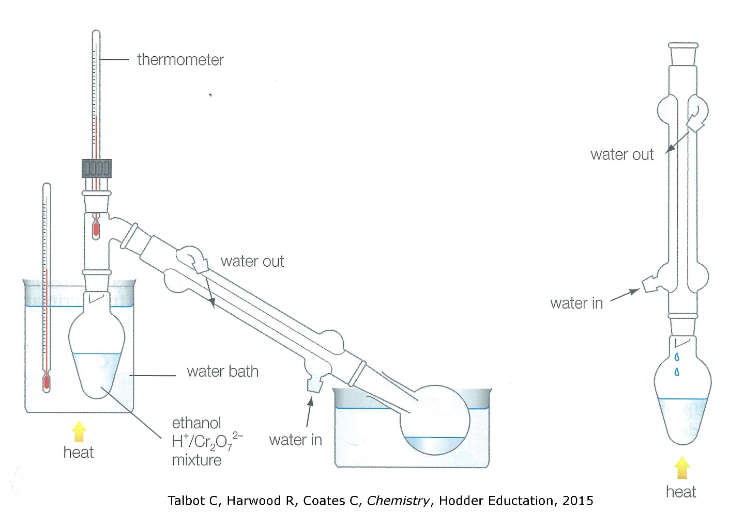
partial oxidation using distillation
ethanol (primary alcohol) forms aldehyde: ethanal (bp of 21°C)

total oxidation using reflux
ethanol (primary alcohol) forms carboxylic acid: ethanoic acid (bp of 120°C)

oxidation of secondary alcohol
propan-2-ol forms a ketone: propanone (bp of 56°C)

distillation  • product is condensed and collected as soon as it forms  • important in the case of forming an aldehyde to prevent further oxidation to a carboxylic acid | reflux  • maintains the boiling point of the reactant, ensuring maximum rate of reaction  • no loss of product as vapours condense and fall back into the pear shaped flask

