Fractional distillation synoptic questions

Learning objectives
- To recall prior learning on bonding, structure and the properties of matter and changes of state.
- To apply this prior learning in the context of fractional distillation.

Introduction

To understand the processes involved in fractional distillation you need to have a secure understanding of a number of concepts including bonding, structure and the properties of matter and changes of state.

The questions in this worksheet ask you to retrieve relevant knowledge and understanding from prior learning then apply it in the context of fractional distillation.

Questions
- State the number of protons, neutrons and electrons in an atom of carbon ${}_{6}^{12}C$.

Protons = __________

Neutrons = __________

Electrons = __________

- State the number of elements present in a molecule of butane, $C_{4}H_{10}$.

Number of elements = __________

- State the total number of atoms in a molecule of butane, $C_{4}H_{10}$.

Number of atoms = __________
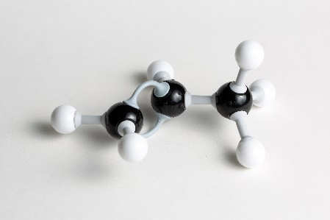
- Give the formula for the hydrocarbon modelled in the image.

Black = C; White = H.

_________________________________
- Octane $C_{8}H_{18}$ is found in petrol. Calculate the relative formula mass of a molecule of octane.

Relative atomic masses: C = 12, H = 1

Relative formula mass = __________

- Methane, $CH_{4}$, is a small, covalently bonded molecule. Complete the dot and cross diagram to show the bonding in a molecule of methane.
C
H
H
H
H

- Explain why methane, $CH_{4}$, is an example of a hydrocarbon.

__________________________________________________________________________________

__________________________________________________________________________________

__________________________________________________________________________________

- Fractional distillation is one separation technique. Name the separation technique you would use to separate the following mixtures:
- The food colourings in a sweet;

__________________________________________________________________________________
- Oil from a mixture of oil and water;

__________________________________________________________________________________
- Sand from a mixture of sand and water;

__________________________________________________________________________________
- Salt from salty water.

__________________________________________________________________________________

- In a fractional distillation column, the crude oil is initially heated in a furnace to convert the hydrocarbon molecules from liquid into gaseous form. Which is the correct option for what is broken when the hydrocarbon molecules turn from liquid to gas? Tick one box only.

☐ Covalent bonds
☐ Ionic bonds

☐ Intermolecular forces

- Explain why hydrocarbons with a longer chain length have a higher boiling point.

__________________________________________________________________________________

__________________________________________________________________________________

__________________________________________________________________________________

- Describe the trend in viscosity of the hydrocarbons as the chain length increases.

__________________________________________________________________________________

__________________________________________________________________________________

- Alkanes have the general formula $C_{n}H_{2n+2}$. State the formula of an alkane containing 28 carbon atoms.

_________________________________
- Heptadecane $C_{17}H_{36}$ is found in diesel. It has a boiling point of 302 °C. What is the state of heptadecane at the point in the fractional distillation column where the temperature is 350 °C. Tick one box only.

☐ Solid
☐ Liquid

☐ Gas

- Complete the word equation for the complete combustion of propane.

Propane + _________________ $→$ ___________________________+________________

- Is the combustion of a fuel an endothermic or exothermic reaction? Tick one box only.

☐ Endothermic
☐ Exothermic

